Age Scale:

|  |  |  |  |  |  |
| --- | --- | --- | --- | --- | --- |
| 0 | 20 | 40 | 60 | 80 | 90 |

What has connected with you from 2 Timothy that might help you go the distance?

What decision(s) could you make now that might help you go the distance?



**The Flaw?**

‘The hardest work I’ve ever done, and the most stressful, was as a parish priest mainly because it was isolated, insatiably demanding and I was on the whole working without close colleagues – and that wears people down.’

Archbishop Justin Welby, The Guardian, 10July 2017.

In which area(S) are you feeling that your spring of resilience is being stretched? Is this a positive stretch or a negative stretch?



### Developing Resilience

1. Strengthen the Spring

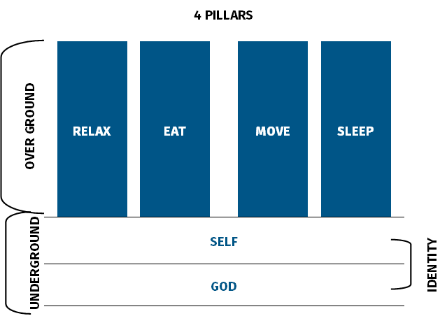

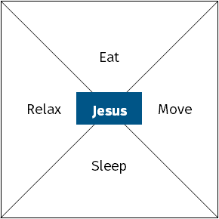

1. Strengthening the Spring

#### Prayer

#### Relax

#### Eat

#### Move

#### Sleep

#### Rank these five areas in order of strength

The think about one (small or big change) you could make to improve each area

**Strongest**

**Weakest**

1. Reduce the Weights
2. Get Support

Who might be the different load bearing people for each area of stretch?



#### Change...

#### Lack of Alignment...

#### Isolation...

#### Unrealistic Expectations...

What are the joys and privileges of leadership?

How can we keep these things before ourselves?

#### 1. Leadership is Demanding

#### 

‘Stop being surprised that leadership is hard.’

Nancy Ortberg

* Leadership is about clarity.

* Leadership requires that we solve problems and manage tensions.

* Leadership requires that we communicate things carefully, creatively and continually.

* Leadership requires that we engage with people with difficulties.

* Leadership can at times feel lonely.

* Leadership requires that we expand our capacity for chaos, change and conflict, and increase tolerance for ambiguity.

#### 

#### 

#### 

#### 

#### 

What would you add?

#### 2. Change Around us is Slow and Incremental

* More agricultural than industrial.

* Keep at it and be intentional.

#### 

#### 

#### 

#### 

#### 3. You Can do Everything Right and it Can Still Go Wrong

* Bizarre but true.

* Don’t beat yourself up, develop a deep trust in God.

#### 4. Reality of Disappointment

Disappointment = _____________________

‘I write with the conviction that learning to cope with disappointment is a key quality for all leaders to develop. Facing disappointment honestly helps us to build resilience, manage expectations and nurture faith and hope in ways which keep our focus on the author and perfecter of our faith.’

James Newcome

You’ve been invited to give a talk to a group of younger leaders on how to deal with disappointment as a leader. What would you say?

#### 5. Boredom

* Same old same ole.

* Keep developing personally and corporately (feedback, feedback, feedback).

#### 6. Life Mixed

* Inevitable ups and downs.

* Work out how to handle personal stuff when in a public role.

#### 7. Our stuff likely to be an ongoing issue

#### 

What are the 2-3 things that are likely to be an ongoing issue for you.

#### 

#### 

#### 

#### 

#### 

#### 

#### 

#### For reflection

* Which of these connects with you?

* How would you start a conversation with your mentor about this?

### What Helps us Press On?

Bobby Clinton’s research identified the following:

* Invest in something significant. This is normally something small and in your context.

* Constantly pursue renewal.

* Continue learning – reading, listening, watching.

* Maintain perspective.

* Draw on support – peers, mentors, intercessors.

* Practise disciplines, they are foundational.
* Manage the tensions between self-care and self-denial.

The Scriptures encourage us to fix our eyes….

Receive a tattoo….

### Guidelines for Quiet Afternoon

* Use the time constructively, be intentional about what you do. The focus of this time is not finishing incomplete integration tasks, reading three books, or preparing the sermon for Sunday! It is on being with God and allowing him to focus on whatever he wants in our lives. So begin the time with an intentional act of giving yourself over to God and being still in his presence.
* To enable quiet within our community, please don’t talk in public spaces and try to move around as quietly as possible.
* Tea/ coffee/ juices will be available at 3.45pm in the Terrace area for you to help yourself.
* Prayer is available in the Round Room and Writing Room. Times are displayed on a sheet in the Terrace. Please tick if you want to use one of the slots.
* Please meet with your sock partner at 5.15pm for 30 minutes to chat about the day and pray for one another.
* We will end the quiet at 5.15pm.

### Ideas

* **Journaling** read through your journal of your time on Arrow. What has God been doing? What are the things he still wants to do? What are the trends you can spot?
* **Review your Development Plans and Personal Vision Statement** What can you give thanks for? Where might God be leading you in the future? What are the changes you want to make to these things for the last part of Arrow (from now until October)?
* **Get creative** Creative materials are available in the Foxton Room. If you don’t normally use such things, think about having a go. Sometimes it can be helpful to express a feeling, approach a problem, or seek guidance using art.
* **Reflecting** Use the questions below to help you reflect on a variety of Arrow things. Alternatively we’ve included two pages in this section to help reflection. One is focused around the Arrow strapline, to be led more by Jesus, to lead more like Jesus, to lead more to Jesus. The other is focused on the five competencies at the heart of Arrow.
* **2 Timothy** Read through your notes on the Bible teaching this week, or use the summary of Paul’s instructions to Timothy in the yellow pages section.

#### Suggested Questions for Reflection During the Quiet Time

* What has God been doing in your life during your time on Arrow? What can you give thanks for?
* What are the key principles for life and leadership that you want to make a part of the rest of your life?
* Where does God want you to pay attention at this point?
* What one thing must you absolutely act upon by the end of your time on Arrow (or even the end of today)?
* What are the conversations it would be good to have with my mentor before the end of the programme?
* Using the handouts on developmental roles and the lifeline overview, what questions might it be good to explore over the coming year and with whom would it be best to explore them?

|  |
| --- |
| To be led more by JesusKnowing Him and Understanding His Will |
| Reflect    * What insights have you gained?                    Review    * Identify the areas where you can rejoice over Jesus’ leadership in your life.                      * What areas of your life would you like to further submit to Jesus’ leadership?                    Revise    * What one thing would you like to do in this area to make the most of your remaining time on Arrow? |

|  |
| --- |
| To lead more like JesusWorking Well with Others to Enable His People to be a Missional Community |
| Reflect    * What insights have you gained?                                  Review    * In what ways would you like to lead more like Jesus?                                  Revise    * What one thing would you like to do in this area to make the most of your remaining time on Arrow? |

|  |
| --- |
| To lead more to JesusHelping People of All Ages Come to Know Jesus in Our Generation |
| Reflect    * What insights have you gained?                                  Review    * What will leading more to Jesus mean for you?                                  Revise    * What one thing would you like to do in this area to make the most of your remaining time on Arrow? |

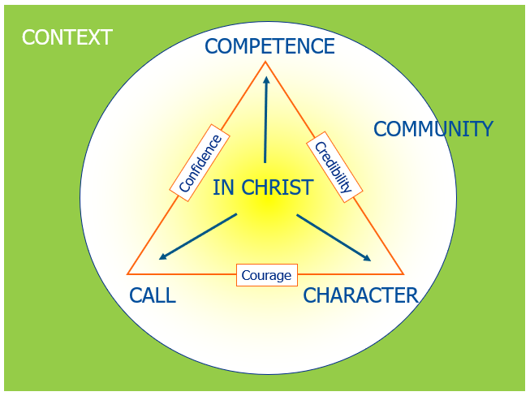

#### Growing leaders know they are chosen

Where are you in your relationship with God right now?

#### Growing leaders discern God’s call

What is God calling you to? Where are you excited? Where are you resistant?

#### Growing leaders develop Christ-like character

What is the character issue God most wants to work on in you? What character issue is likely to scupper you in leadership?

#### Growing leaders cultivate competence

Where are your strengths in leadership competence? What are the key areas for growth over the next year?

#### Growing leaders lead in community

Who are you leading with? What would take your leadership with others to the next level?