### Introduction

* Biblically leadership is plural not singular.

* Practically leadership is best exercised with others not on our own.

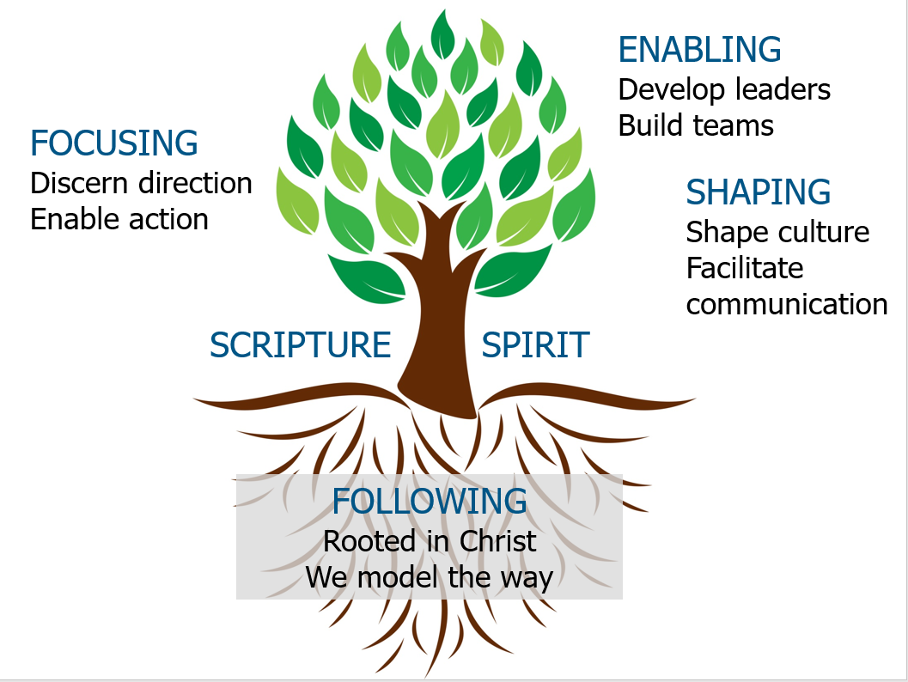

 ‘The biggest challenge of all: the myth of too many meetings. While it is true that much of the time we currently spend in meetings is largely wasted, the solution is not to stop having meetings, but rather to make them better. Because when properly utilised, meetings are actually time *savers*.’

Patrick Lencioni

### Leading Great Meetings

Some statistics

A myth

An axiom

#### An exercise

What are your pet peeves about meetings? Please place one on each Post-it note.

What are the meetings you’re involved in? Please list:

Now choose a more formal style of meeting you are regularly involved with where you would like to see some improvement as your ’case study’ for the day.

#### Two questions

Is this a safe environment which facilitates rich discussion?

Am I continually reminding people of the ‘big’ picture?

If meetings go wrong, it is generally for one of four reasons:

* Badly organised.

* Badly run.

* People awkward.

* No follow through.

#### A structure for meetings

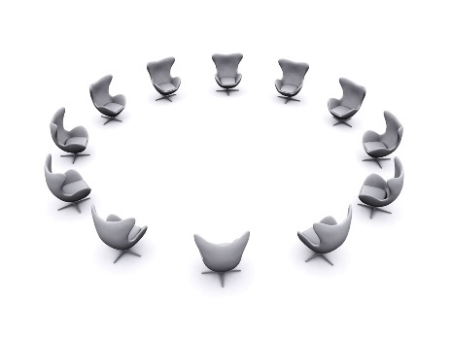

#### Run

#### Follow up

#### 1. Plan

* Why are we having this meeting?

* When is the best time to hold the meeting?

* Where is the best place to hold the meeting?

* Who needs to be there?

* What is the best way to run it?

#### 2. Create an appropriate agenda

* Not just what they contain, but how they ‘feel’.

* Be realistic about timings.

* No AOB at end.

* Last item = review of meeting.

* Guided by yearly overview.

* Sent out on time.

#### 3. Identify supporting materials

#### 4. Prayer

### 

#### 5. Venue

### 

### 

### 

### 

### 

### 

Using your ‘case study’, how will you prepare well for your next meeting? What might you do differently than before?

#### Run

#### Follow up

#### Steering conversations

* Clarifying purpose.

* Summarising where got to.

* Refocusing.

* Energising.

#### Guiding contributions

Enabling every voice to be heard.

#### 

#### 

#### MINING CONFLICT

#### Creating a code of conduct

#### 

#### Handling awkward people or moments



You can predict 90% of awkward moments that are likely to occur in a meeting, therefore it is worth taking some time to think how you would respond if they crop up.

#### Selecting the best processes

### Thinking

### 

### Problem Solving

Ask:

* How long are we going to give this?
* What sort of outcomes are we looking for?
* Who needs to contribute at what stage?
* Who will oversee this?

Edgar Schein’s problem-solving approach.

|  |  |
| --- | --- |
| Skills/tasks | Process |
| * Initiating        * Information-seeking        * Information-giving        * Opinion-seeking      * Opinion-giving        * Clarifying        * Elaborating        * Summarising        * Deciding | 1. **Explore needs**  * Collect what people are initially thinking and feeling about what is needed. * What is on people’s hearts and minds? * What are the key issues? |
| 1. **Look for the bigger picture**  * Stand back to see the common themes. * Piecing together what everyone has said – what is the overall pattern saying? |
| 1. **Define objectives – write three clear statements!**  * The nature of the problem/opportunity. * What the team is aiming to achieve and why? * Measures of success. (What will you see/hear/feel to know that the team has been successful?) |
| 1. **Brainstorm all your options**  * Brainstorm everyone’s ideas for possible solutions. Be creative! Generate many possibilities – the more the better! |
| 1. **Weigh up the implications of the options**  * What are the likely consequences? * What are your priorities and decision-making criteria? * Link back to your measures – choose the best option! |
| 1. **Create a plan of action**  * What to do, how, by whom, by when? * And then do it! |
| 1. **Review progress**  * Ask people what they have done. * Evaluate against objectives and measures. * • Adjust plans and make new commitments. |

#### Decision making

There are three basic ways decisions are made in meetings. Each of them has its advantages and disadvantages, and each is appropriate at certain times.

* **Closed** No input from others. The person leading the meeting decides something on behalf of the group.

* **Consultative** Seek input from group and get to a point where it is clear what the decision is, or where either a vote is taken or someone makes the decision on behalf of the group having listened to all the different views/ideas. Quite often people won’t mind if a decision doesn’t go their preferred way if they have been genuinely listened to.

* **Consensus** Where all need to be in agreement before a decision is made. Another version of this is when a group decides a percentage threshold for a decision i.e. 75% or 90% of the group must be in agreement before we can go ahead.

Certain approaches to decision making take into account varying personality types.

* **A decision over three meetings** Here the item is introduced at the first meeting with a clear explanation of what the issue is, why it is important and the sort of decision that will be required. At the second meeting it is discussed, but divorced from the decision, which allows people to be a bit more open to the conversation, and then for those who need space to reflect to do so following the meeting. Then at the third meeting, any new insights are offered (not a rehearsal of the previous discussion) and a decision is made.

* **Decision making in the round** The item for discussion is clearly identified. Each person gets to speak once in a round. No interruptions are allowed. The discussion lasts for as many rounds as necessary until a sense of the best way forward emerges. It helps people to listen, prevents domination by any individuals, encourages the quieter voices, and actually can speed up decision making as people listen well.

* **Checking commitment to decisions** When making important decisions be sure to understand what people mean when they say/vote yes. You can check this out on a scale of 1 to 5 where 1 = not at all committed to seeing this happen and 5 = I will die to make sure this happens.

### 

#### Run

#### Follow up

### 

### 

### 

### 

#### Circulate materials

#### 

#### 

#### 

#### 

#### 

#### 

#### 

#### 

#### Implement action

#### 

#### 

#### 

#### 

#### 

#### 

#### 

#### 

#### Review action

#### 

#### 

#### 

#### 

#### 

#### 

#### 

#### 

#### 

#### Communicate

#### Purpose of managing people

* Enable people to fulfil the requirements of their role in alignment with mission/vision.

* Help the person to flourish and develop them for their next role, in or outside.

* Care for the person through ups and downs of life.

#### The four things that most help people to excel in a role

* Select the right person.

* Set clear expectations focused on outcomes.

* • Motivate by focusing on strengths.

* Care for whole person.

Managing people is about turning talent into performance.

### 

# 1

### Create Good Systems

* Tailor to individuals.

* Role profiles.

* Regular meetings.

* Complaints / disciplinary procedures.

# 2

### Delegation

*Empowerment* occurs when an ‘established leader gives authority to an emerging leader within specified boundaries but retains overall responsibility’ (Malphurs). It is not easy for many leaders because it involves giving up control, slowing down to give time to others, humility, and building connection with other people.

#### Poor ways to delegate

* **Directing** occurs when an established leader retains both responsibility and authority. In some circumstances this is wise and necessary, but generally it inhibits leadership development.

* **Abdicating** occurs when an established leader gives away both authority and responsibility. This means a vital connection between the existing leader and the emerging leader is lost. It usually occurs unintentionally through neglect and is perpetuated by stress and time constraints in the established leader’s life.

* **Disabling**occurs when an established leader gives away responsibility but keeps authority. This cripples the emerging leader because they can’t make decisions and do things their way.

‘Work for those who work for you.’

Steven Sample

#### Identify something you need to delegate at this time

* Why?

* To whom?

* When?

* How?

* What is your next step?

‘I really love working in teams, but I do find it quite hard and in all honesty I prefer getting on and doing it on my own or working with people when I am telling them what to do.’

Arrow participant

### Feedback

#### Creating a culture of feedback

The basis of good feedback is a culture of affirmation and encouragement.

* Invite it.

* Accept it.

* Apply it.

* Offer it.

 ‘Without feedback it is remarkably difficult to grow.’

Ed Vaughan



**B** alanced: focus on building on strengths, working on gaps, managing around limitations, dealing with flaws, growing through weakness.

**O** wned: by the one offering feedback. Don’t say ‘some people think…’

**O** bservable behaviours: as much as possible focus on tangible things and remove emotion and judgementalism.

**S** pecific: not ‘it wasn’t very good’ but ‘I am not sure x worked well when you did y because it led to a, b and c.’

**T** ailored: to their preferred way of receiving feedback.

# 3

‘Spend 10% of your time getting staff in place. Spend about 90% of your time doing everything you can to help them succeed.’

Steven Sample

#### Feedback – application

Identify someone to whom you could offer feedback

* Who?

* What about?

* How would you BOOST it?

* When might you do it?

Identify an area where you could invite feedback for yourself

* What is it?

* Who from?

* When will you ask?

* How can you best prepare yourself to receive it?

# 4

### Encouragement

### The Motivation of Volunteers