### Review

The role of the leader in evangelism:

* Connecting.

* Modelling.

* Mobilising and ordering.

### 

### 

### 

### 

### 

### 

### 

### 

### 

### 

### 

### 

⇒ Shaping an evangelistic culture.

⇒ Discerning a strategy for evangelism.

⇒ Equipping ordinary people to play their part.

⇒ Engaging evangelists and pioneers.

### 

‘I think it is more helpful to think of evangelism as an art rather than as a science, being in the proper sense adaptive rather than programmatic.’

Paul Weston

**Dwelling in the Word is a process that many people are using to listen to Scripture, to each other and to God. It’s not about sharing information or seeking scholarly answers or even the right answers to the issues raised in the text, but it is about listening well to one another and discerning what God is up to amongst us.**

**We invite the Holy Spirit in prayer to open our ears, hearts and minds. We listen to the passage read out loud and notice where our attention is drawn – a verse, phrase or single word. We then remain in silence for a minute or two, staying with the place in the passage that stood out for us.**

#### Luke 10:1–12

1 After this the Lord appointed seventy others and sent them on ahead of him in pairs to every town and place where he himself intended to go. 2 He said to them, “The harvest is plentiful, but the labourers are few; therefore ask the Lord of the harvest to send out labourers into his harvest. 3 Go on your way. See, I am sending you out like lambs into the midst of wolves.

4 Carry no purse, no bag, no sandals; and greet no one on the road.

5 Whatever house you enter, first say, ‘Peace to this house!’ 6 And if anyone is there who shares in peace your peace will rest on that person; but if not, it will return to you. 7 Remain in the same house, eating and drinking whatever they provide, for the labourer deserves to be paid. Do not move about from house to house. 8 Whenever you enter a town and its people welcome you, eat what is set before you; 9 cure the sick who are there, and say to them, ‘The kingdom of God has come near to you.’ 10 But whenever you enter a town and they do not welcome you, go out into its streets and say, 11 ‘Even the dust of your town that clings to our feet, we wipe off in protest against you. Yet know this: the kingdom of God has come near.’ 12 I tell you, on that day it will be more tolerable for Sodom than for that town.”

|  |  |
| --- | --- |
| 1 | We each turn to a person in our group. If there is someone you don’t know so well engage with them. |
| 2 | We listen to that person as he or she says what they heard in the passage in a particular verse, phrase or even single word. They may mention something they’d never heard before, something odd or something comforting, or something about which they’d like to find out more about. |
| 3 | Listen well, because your job will be to report to the rest of your group what your partner has said, not what you yourself said. Some people even take notes to help them focus and remember. If you don’t yet know each other well, introduce your partner by name to the group and then share what you heard them say. Each one takes their turn when they are ready to speak. |
| 4 | If there is time a conversation develops around what God is saying to us today from the themes arising in the whole group. It can be helpful for the group co-ordinator to keep a brief note of themes and insights that arise. |

Adapted from Church Innovations (www.churchinnovations.org)

**Dwelling in the Word. So that the Word dwells in us.**

### Evangelism as a Body Ministry

‘Everyone has a part to play and we need everyone to play their part.’

#### 1. Context

All people are **hungry**:

* Desire for belonging (love, intimacy, community).
* Desire for fulfilment (purpose, meaning, adventure).
* Desire for sense (identity, suffering/struggle, death, forgiveness).

Some are **hostile:**

* Not so much apathetic, antagonistic.
* Survey Theos Aug 2018, 47% thought world would be more peaceful without religion, 38% disagreed, 16% undecided.

And generally things are very **varied:**

* True most extraordinarily ignorant about Christian things, but not all.
* True most think little about life after death, more interested in making most of life now (happy midi-narrative), but not all.
* True many are more conscious of doubt than guilt, but not all.
* People are varied because six generations of people alive today.

### 

### 

#### 2. Expectations

### 

### 

‘Nothing is more deadly than a Christian who is indifferent to the salvation of others. Indeed I wonder if such a person can be a true Christian.’

John Chrysostom

#### Multi-faceted households

#### Research on families

(see Faith in Our Families on Arrow webpages)

#### 

* 41% of practicing Christian attribute their faith to growing up in a Christian home (Talk Calling).
* 28% of church attending Christians report they do not mind whether or not children share their beliefs.
* Among Anglicans who say that religion is very important in their lives, only 36% listed religious faith as especially important quality that children can be encouraged to learn at home, compared to good manners 94%.
* Only around 50% of children brought up in Christian homes still follow the faith as adults.
* 36% of parents surveyed felt very confident in nurturing their child’s faith, whereas 26% felt less confident. How confident a parent felt had a significant relationship to their views on nurturing faith and what they currently do at home.

The key factors that increase the chances of children choosing to follow their parents’ faith are:

* Children feel close to their parents and grow up in a warm family.
* Children see that their parents have a developing, authentic (not perfect) faith themselves.
* Parents seek to develop and nurture their children’s faith.
* Children receive positive multi-generational input from the wider family and church.

#### vision



#### ACTIVITY

Create an approach to equipping people to share their faith in your context from January 2020 to December 2020. Take into account the ‘brakes’ we identified last time, and the various resources available today.

### 

### Pioneers

A definition of a pioneer: a person called by God who has the character and gifting to respond first to the Holy Spirit’s initiatives within a particular context and to create with others something in response to these promptings that opens up new horizons.

#### Pioneer Spectrum

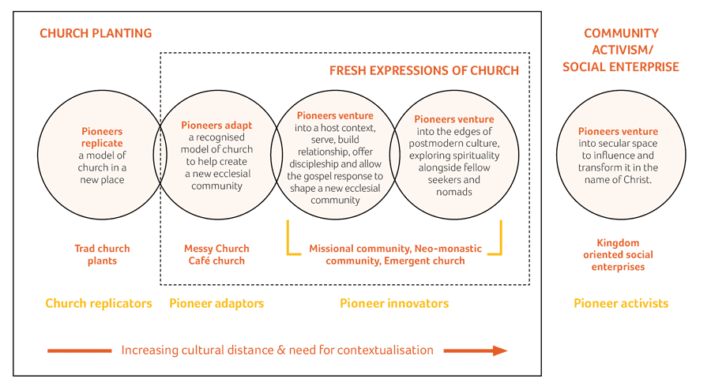

‘Pioneering leadership is so important for the future of the Church. We can no longer afford for most of our leaders, both lay and ordained, to be trained, equipped, formed and deployed to continue leading in the way leadership has operated over the last few hundred years.’

Dave Male

#### Common Traits

Dave Male identifies ten common traits in his Grove book Pioneering Leadership, and stresses most won’t have all these qualities, but are likely to exhibit many.

1. They are people who are first and they love firsts.
2. They are on the edge. They feel more at home on the borders.
3. They enjoy taking risks.
4. They like people. They like to build community.
5. They are robust characters with the ability to respond to their calling in a particular context even when it seems crazy to do it.
6. They know when to stay or go.
7. They know when to bring order or chaos.
8. They are often thinking about moving out, pushing boundaries.
9. They are dissenters. They often ask difficult questions.
10. They are able to reflect, connect and not know. They don’t have to have all the answers, are happy to ask questions.

### Pioneering in Your Context

Who do you know in your context who might exhibit some of these traits?

Where might it be good to prayerfully initiate some pioneering work in evangelism?

How might you equip and release the pioneers in your context?

### Evangelists

Evangelists are a gift to the Church. They help a church by modelling good evangelistic practise, by encouraging others in their evangelism, and by mentoring future evangelists. Identifying evangelists is a priority for those in church leadership in order to maximise their contribution to the life of the church.

The Bible indicates that God gives spiritual gifts to his people, and that some are gifted as evangelists. However evangelists need to be considered in the context of the Bible’s teaching on evangelism.

‘The evangelist is a gift ministry… however, there is nothing in the New Testament that declares the evangelists are only meant to operate in particular ways, or for that matter on a particular scale. There have been many truly gifted evangelists over the years that nobody has heard of, and who have never filled a church hall let alone a stadium.’

Gavin Reid

#### God is a missionary God

The father sends his Son into the world; the Son sends his Spirit on the Church; the Church is sent to the world. God’s people are caught up in God’s mission to God’s world. All Christians are called to show and share the faith to those outside the faith. This involves us in (Colossians 4:2-6):

* Dedicated prayer.
* Clear proclamation.
* Wise engagement.
* Maximising opportunities.

#### Evangelism is a body ministry

Although all Christians are called to the above, each person will have different parts to play within the overall mission of the Church. But because mission is central to the heart of God it must be central to the life of the Church. It is not an optional extra for the few. Evangelism is not the preserve of special people at special times doing special things. It is the church living out its faith and speaking about Jesus in everyday life.

#### The evangelist is not the person we look to do our evangelism ‘for us’

Just as someone who has the gift of intercession can’t do our praying for us. The evangelist is someone whom God gifts in a special way in evangelism to help the church to be all that it is meant to be. Evangelists are not meant to be on the edge of a church, regarded as awkward people to be tolerated, rather they are meant to be at the heart of a Church, recognised as vital for the health of a church as they exercise their ministry.

### But How do we Identify Evangelists?

1. Recognise that the evangelist is on a continuum from witness to evangelist, and the exact point at which you may describe someone as an evangelist may be difficult to identify.
2. Recognise that as a ‘gift’ from God it is not dependant on the age, background, gender, personality type, or experience of the individual. God gives the gift to whomever he pleases.
3. Recognise that God can and does take natural abilities (e.g. relational skills) and empower them for use as spiritual gifts for his kingdom.
4. Recognise that like all gifts, its usage can be hampered by selfishness, disobedience, immaturity, lack of accountability, lack of use, and a desire for personal gain.
5. Recognise that there are different types of evangelist.

⇒ **Public proclaimer evangelist** This may be local or itinerant, but the person will have a ‘one-to-many’ aspect of their ministry. (Other gifts likely to be associated with this type of evangelist are teacher and

⇒ **Leader-evangelist** Part of the leadership team of a church, responsible for the shaping of the mission that then shapes the church. (Other gifts likely to be associated with this type of evangelist are leader and

⇒ **Personal evangelist** May never speak in front of a crowd, nor be part of leadership of church, but faithfully draws people to Jesus.

1. Recognise for each of these types, there are many different ways they may be exercised e.g. creative arts.

### Common Characteristics of an Evangelist

#### Concern for people outside the church

* The evangelist has a love for lost people and longs for them to love Christ.
* The evangelist tends to think of such people first in any decisions made within the life of a church. How is this going to impact those who aren’t yet Christians?
* The evangelist tends to consider any opportunity to meet with those outside the church as a potential opportunity to share the faith.
* The evangelist longs that every other Christian would play their part in sharing the faith.

#### Ability to relate to people outside the church

* The evangelist relates well with those outside the church, understanding their world and making connections with them.
* The evangelist may well prefer spending time with those outside the church.

#### Ability to explain an aspect of Christian truth

* The evangelist can communicate the Christian message with clarity and conviction.
* The evangelist can connect the Christian message with people’s needs.

#### Ability to help people take the next appropriate spiritual step

* The evangelist has ‘volitional intelligence’. They sense where people are, what will help them take the next step, and long to serve in helping them take that step.
* The evangelist appeals to the will.

#### Indebtedness to the grace of God

* True of all Christian people, but vitally important in the evangelist, otherwise they can be motivated by a range of unhelpful factors that may lead them to manipulate others or inappropriately drive themselves.

Important note: ability is made up of skill, knowledge, talent and gift. When all four are present the individual will be competent in this ability. Skills can be learnt through training and experience. Knowledge can be acquired through learning. Talents are formed by the time you are an adult, but need nurturing and developing for effective use. Gifts can be given by God at any time.

### Process for Identifying Evangelists

#### Why evangelists are important to the life of the Church

A leader is unlikely to spot an evangelist if they don’t value the role of the evangelist within the life of the church.

Too often the assumption is that evangelists are often disconnected from the local church. But Ephesians 4 suggests they should be wedded into the body, exercising their ministry just like anyone else.

‘Evangelists must be in Christ, seeking to live lives modelled on Christ, proclaiming the gospel of Christ, equipping the saints of Christ, from within the body of Christ.’

James Lawrence

When evangelists are integrated into the life of a church they will permeate the church with an outward looking mission focus. They will be part of shaping the culture of the church.

#### How to spot an evangelist

Like all gifts, the main way to spot them is by their fruit. Evangelists are uncommonly fruitful in helping people become disciples of Jesus Christ. This may be an ability to get alongside people and draw them into the life of the church; an ability to explain their faith or the faith in a way which engages with people; an ability to help people make a commitment to following Jesus.

All of us have a part to play in evangelism, but the evangelist will be more fruitful than most, and is likely to be more passionate than most.

‘A person with the gift ministry of evangelist is not only someone who evangelises. He or she, by exercising that ministry, encourages and reminds the whole church of its calling to evangelise. Properly used an evangelist stimulates rather than inhibits congregational evangelism.’

### Evangelists in Your Context

Who do you know in your context who might exhibit some of these traits?

How might you equip and release the evangelists in your context?

### Why is Fueling Motivation so Important?

‘The best decision anyone can ever make, at any point in life, in any circumstances, whoever they are, wherever they are, whatever they are, is to become a disciple of Jesus Christ. There is no greater decision for a human being in this life, any human being.’

Justin Welby

‘I would suggest to you the purest motivation for evangelism is vision. Vision means to see the world and all the people in it as God the Father sees them.’

Leighton Ford

#### Identify

* Top ten ways to fuel motivation for evangelism.

* Ten ways we unintentionally demotivate people for evangelism.