### The Leadership Track

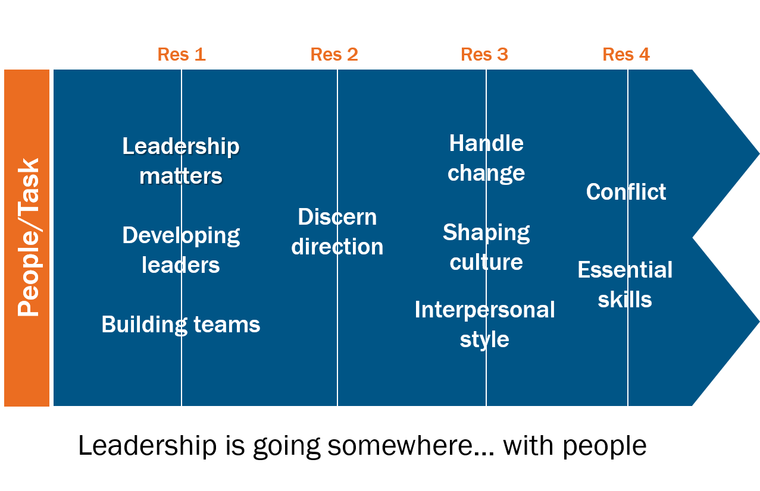

 Pay close attention to yourself and to your teaching; continue in these things, for in doing this you will save both yourself and your hearers.

1 Timothy 4:16

|  |  |  |
| --- | --- | --- |
| Inner life  * Relationship with Christ * Character * Vocation * Emotional intelligence * Resilience |  | Outer life  * Relationship with others * Competencies * Responsibilities * Emotional intelligence |

 

### Always True of Leadership

* Leadership is complex.

‘Leadership is ultimately a mystery which no one fully understands.’

John Adair

In pairs complete the following sentence as many times as you can in five minutes, and choose one each to write up in large letters on an A4 sheet of paper using a marker pen to ‘display’ when we gather back.

Leadership is more ______________ than ________________

* Leadership is messy.

‘True leadership is difficult and complex. The exercise of leadership will stretch us and test us to the limits of what we can bear.’

Steve Croft

### Specific to Leading Through the Pandemic

#### CRISES EXPOSE AND ACCELERATE

**Changing Church Report**

Published by the Evangelical Alliance, Stewardship and EIDO, January 2022.

#### 

* 61% offering services online.
* 32% drop in average onsite attendance.
* 24% church-run youth ministry stopped.
* 59% churches decrease in volunteering (25% significant decrease).
* 60% decrease in congregational giving.

#### Key leadership Qualities shift

* Empathy.

* Transparency.

* Agility.

* Clarity.

#### For reflection

What have you learnt about leadership over the last two years?

Where has the pandemic left you as a leader?

‘The Judaeo-Christian tradition provides the longest continuous source of reflection on questions of leadership in the whole of human history.’

Steve Croft

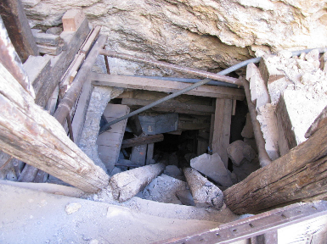

Define the characteristics of Christian leadership from engagement with the Scriptures. Select four to write up on your flipchart paper.

### Image One – Shepherds of God’s Flock

#### Ezekiel 34:1-10

* What are the characteristics of the bad shepherds?
* In what ways have you seen leaders using their leadership role to meet their own needs? (Jude 12)

#### John 10:11-18

* What are the characteristics of the good (word used here doesn’t mean morally good, but skilled, proficient, able) shepherd?
* How might these impact your own leadership?

#### 1 Peter 5:1-4

* How does this passage shape our understanding of being under-shepherds?

### j0422656Image Two – Steward of All that God Gives

#### Matthew 25:14-40

* What do we learn from this passage about the stewardship of God-given talents?
* Who have you seen steward their God-given talents well? What did they do?
* What prevents you from stewarding your God-given talents well?

### Image Three – Servants of the King

#### Matthew 20:17-28

* What insights do we gain from this passage on ‘servant leadership’?
* What does and doesn’t it mean to be a servant leader?

#### Philippians 2:1-11

* How does this passage inform our understanding of servanthood as modelled by Jesus?

### 1384593913951392427Bible Words for Leadership

Below are a variety of words associated with those exercising leadership roles within the New Testament.

#### Doulos – Slave

‘Paul a doulos of Jesus Christ’ (slave, not servant) – Romans 1:1; Philippians 2:7.

### 

#### Diakonon – Servant

‘I am among you as the one serving’ – Luke 22:24-27; Acts 21:19.

#### Kyberneseis – Pilot

‘And God placed some to be… governings…’ (‘pilot’ or ‘helmsman’ not administrator. Kyberneseis used in Acts 27:11 and Revelation 18:17 in ordinary sense of pilot. Word was used by Greeks to speak of the art of government, guiding the ship of the state.) – 1 Corinthians 12:28.

#### Huperetes – Under rower

‘For I appeared to appoint you as an attendant (an ‘under rower’, a subordinate acting under another’s direction) and a witness’ – Acts 26:16, 1 Corinthians 4:1.

#### Leitourgos – Minister

‘Because of the grace given me by God to be a minister’ (used in Greek to describe a public servant or minister in a representative role) – Romans 15:16.

#### Episcope – Overseer

‘Keep watch over yourselves and over all the flock, of which the Holy Spirit has made you overseers, to shepherd the church of God…’ – Acts 20:26, Titus 1:7-9, 1 Timothy 3:1-7.

#### Presbyter – Elder

‘And when they had appointed elders for them in every church…’ – Acts 14:23.

#### Hegemenon – Leaders

‘Remember your leaders (guides, only used here in the New Testament) who spoke to you the word of God, consider the outcome of their life…’ – Hebrews 13:7.

#### Architekton – Expert Builder

‘According to the grace given to me, I laid the foundation as a wise expert builder…’ – 1 Corinthians 3:10,   
Ephesians 4:11-16.

#### Proistemi – Lead

‘Having gifts that differ according to the grace given us; let us use them… the one taking the lead (literally to stand before, to lead, to attend to, indicating care and diligence) in diligence…’ – Romans 12:8, 1 Timothy 3:4.

#### Sunergo – Co-Workers

‘For we are fellow workers for God…’ – 1 Corinthians 3:9, Romans 16:3.

#### What others have to say

‘From the perspective of the Christian tradition, the exercise of church leadership is primarily about character and virtue and integrity before it is about skills, knowledge or proficiency. This is not say that such skills are unimportant, simply that personal qualities take priority.’

Steve Croft

‘Leadership is a relational process of social influence through which people are inspired, enabled and mobilised to act in positive, new ways, towards the achievement of God’s purposes.’

Understanding Christian Leadership, Ian Parkinson

‘Leading yourself is largely about living a rhythm of life that renews the life of God within us.’

Nancy Ortberg

‘When we consider responsible stewardship of our talents, we are likely to serve him more effectively by investing that which God has planted in us… rather than by trying to force in that which he did not put there in the first place.’

Jonathan Frank

‘Sometimes the use of this servant concept has resulted in an abdication of leadership, particularly when it was mistakenly understood to imply that the servant's primary role was to meet the demands of those he or she was called to serve. This is a serious misunderstanding of the servant role of Jesus, who was first and foremost the servant of his heavenly father.’

Eddie Gibbs

‘Servant leadership is community directed. It uses power for the growth of those who are being led and the accomplishment of the shared mission of the community.’

Walter Wright

‘Servant leadership is not an impossible ideal in our day. Rather it should be the foundational cornerstone of our thinking about spiritual leadership. Christ lived, taught, and modelled it for us, and it is our true distinctive as believers.’

Stacey Rhinehart

### The Difference Between Ministry and Leadership

Write down everything you have done in your working life over this last week.

#### Ephesians 4:7-16

### Definitions

* **Ministry** is any activity which serves the needs of people.

* **Leadership** is any activity which directs, influences or facilitates ministry by others.

## 0 20 70 250

From Empowering Church,Ian Jagleman

‘As spiritual leaders, we must be constantly on the alert against methods, gimmicks, marketing strategies, techniques... that are manipulative methods.’

Marva Dawn

#### For reflection

Reflecting on your mix of ministry and leadership:

* How much time do you spend on these activities?

* How do you view that mix?

* What adjustments might be helpful?

### What are the Responsibilities of Those in Leadership?



### Introduction

There are certain things that are required of good leadership. This diagram identifies seven main areas, each of which contain a range of things that need to be done. Obviously no one leader will be expert in all these areas, that is why leading with others is so important, but it is the responsibility of those who are in overall leadership to ensure these things happen for effective leadership to occur.

### Modelling

#### Rooted in Christ we Follow Him and Watch Over Ourselves

This is at the heart of our understanding of Christian leadership. In Acts 20:28 Paul says to the elders at Miletus ‘Keep watch over yourselves and over all your flock, of which the Holy Spirit has made you overseers.’

Keeping watch over ourselves involves being rooted in Christ, allowing Christ to shape our character and form our priorities. Christian leaders are first and foremost followers. This is worked out in modelling behaviour, clarifying values, and inspiring trust through self-leadership and ongoing transformation into Christ-likeness:

* We grow as a disciple in relation to God, exercising spiritual disciplines. Good leaders are secure in who they are in Christ.
* We grow as a leader in orderliness: use of time, organisation (diary, desk, computer, time keeping, preparation), decision making, energy management (health, diet, sleep, exercise, stress), embodying values, handling failure and criticism, receiving feedback, growing self-awareness, personal development and accountability (mentor, spiritual director, peer group).

### Focusing

#### 1. Discern Direction

Leadership is about going somewhere, and it is the responsibility of those who lead to help God’s people discern God’s direction for the future.

This may be at the micro-level (Acts 6:1-7 how the ministry is organised for the future growth of the church) or at the macro-level (Acts 11:19-30 how the wider picture of what God was doing determined the future actions of the disciples). Prayer, creative thinking, wise innovation, and taking initiative are important parts of the discerning process. For the leadership of churches today it involves:

* Clarifying the identity (who are we?) and mission (why does the church exist?) of the church. Without clarity at this level it is very difficult to progress to the next level of discerning direction.
* Identifying a process that involves people and leads to ownership of the outcome.
* Overseeing the process through to a conclusion.

#### 2. Enable Action

Vision needs to be implemented through appropriate action. Without this ideas aren’t turned into action. The scary statistic is that 60% of visions aren’t acted upon.

Nehemiah provides a good case study of someone who saw clearly what needed to be done (1:1-11) and then planned carefully how to do something about it (2:1-16). Then he shares the vision with others (2:17-18), oversees the work (3:1-32), and changes his plans according to situations he encounters (4:1-23).

It involves leadership in:

* Capturing the big picture in practical next steps.
* Constantly communicating the vision so that it is known, owned, shared and acted upon.
* Ensuring action takes place through four key skills: culture creation, problem solving, managing change, and handling conflict.
* Celebrating things that take you in God’s direction.
* Changing the direction through evaluation (involving feedback review, and revision), experimentation and contingency planning.

### Enabling

#### 1. Foster Collaboration

In the New Testament all the references to leadership except two are in the plural. Christian leadership is not meant to be a solo operation, but a team experience where the gifts of the team complement and balance one another.

Theologically this corporateness reflects the nature of the body of Christ and of God himself as Trinity. Therefore a priority of those in leadership is to lead with others by fostering collaboration. This involves:

* Modelling good team leadership as the overall leadership of a church through effective patterns of team working.
* Developing teams where they are appropriate.
* Providing resources and training to aid team development.

#### 2. Develop Leaders

In order for the ministry to flourish leaders need to choose today’s leaders and develop tomorrow’s, otherwise the work is limited to those already involved in leadership and there is no succession process. Jesus draws around him a variety of different groups whom he invests in (the twelve in Luke 6, a wider group in Luke 8, the seventy in Luke 10).

This involves:

* Identifying both emerging and existing leaders through helping people discern God’s call and discover their talents, spiritual gifts, passions, temperament.
* Investing in them through both generic and specific leadership training that develops them in a Christ-centred leadership.
* Entrusting them with leadership responsibility appropriate for their age and stage.
* Resourcing them through line-management, training, mentoring, appraisal.

### Animating

#### 1. Shape Culture

Leaders are ‘cultural architects’, shaping the environment in which everything happens. For Christian leaders this is a gospel and kingdom culture, where the values of the kingdom are central to how we operate as God’s people. Culture change isn’t easy, but it is part of leadership.

It involves:

* Identifying values that we want to positively influence behaviours.
* Modelling the culture we want to see.
* Affirming (through stories, symbols and celebrations) behaviour that reflects the culture.

### 

#### 2. Facilitate Communication

Little happens in leadership without communication, everything from public proclamation of God’s word to a congregation through to one-to-one listening to a frustrated individual. Most leaders think they do a better job in this area than they actually do.

In Acts we see instances of great communication (Acts 2:14-41) and examples of where communication went wrong (Acts 15:36-41).

Effective leadership is exercised through careful communication which involves:

* Active listening through asking great questions.
* Public speaking through preaching, teaching, training, and leading meetings.
* Written communication.
* Negotiating for oneself and mediating for others.
* Networking for constituency building.

### Context, Resources and Focus

Three further factors influence leadership responsibility.

#### Context

Who is responsible for what? For leadership to be effective it needs appropriate and clear structures. In an Anglican context clarity about how the minister relates to the Church Wardens, PCC, (and possibly other staff, a leadership team, other types of leaders) is vital in determining the effectiveness of leadership.

#### Resources

What are the primary resources for those in Christian leadership? Throughout Church history the two primary resources have been **faithful engagement with the Bible** as God’s word and **prayerful dependence on the Spirit** as God’s empowering presence. Christian leaders do not decide for themselves what they do, the Scriptures inform them of God’s purposes for his people. Nor do they depend on themselves for the strength to lead, the Holy Spirit equips and empowers God’s people for God’s work.

#### For reflection

Of the six leadership responsibilities, where do you feel most at home?

Where do you feel least at home?

#### Focus

Why do Christian leaders do these things? Not because they want to look good as leaders! Leadership is never an end in itself in the Bible, it is a means to a greater end. Leaders are called to be servants, serving the priorities of the King and the purposes of the kingdom. The gift of leadership in Romans 12:8 is given to enable the body to function well, so that the body may be about its master’s work – helping people come to know Christ and transforming the world.

‘You cannot excel in leadership by merely fixing your weaknesses. To excel, you must maximise your strengths.’

Aubrey Malphurs

### Build on Your Strengths

The things you have and can’t help yourself doing.

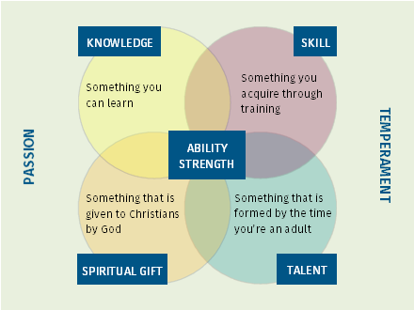

Talent x Investment = Strength.

#### For reflection

What are your strengths, the things that when you do them they bring ‘strength’ to you?

### Work on Gaps

Things don’t have, but can get.

#### For reflection

What are your skills gaps it would be good to fill?

What knowledge would it be beneficial to gain?

### Manage Around Limitations

Things don’t have, and can’t easily get.

A limitation is anything that gets in the way of excellent performance in your role.

#### How to deal with talent limitations

#### For reflection

What are your limitations?

‘God can achieve his purposes either through the absence of human power and resources, or the abandonment of reliance on them. All through history God has chosen and used nobodies, because their unusual dependence on him made possible the unique display of his power and grace. He chose and used somebodies only when they renounced dependence on their natural abilities and resources.’

Oswald Chambers

### Grow Through Weaknesses

Things do have, but don’t want.

#### 1. Infirmities, 2 Corinthians 12:7-10

#### 2. Ordinariness, 1 Corinthians 1:26-29

#### For reflection

What are the infirmities you currently face?

What can you do to embrace ordinariness?

‘‘All human beings have their flaws, but not all of us realise them, come to grips with them, or offset their negative impact. As a group whose primary endeavour is interacting with people, leaders must accomplish the paradoxical task of managing their darker sides.’

Abraham Lincoln

### Engage with Flaws

Things do have, and often avoid.

Cracks in our character that, not properly dealt with, will derail our lives.

#### For reflection

What flaws are you currently aware of?

### Kingdom Paradox 1

If we want to lead, we must first be led.

 ‘But I am also getting in touch with the mystery that leadership, for a large part, means to be led.’

Henri Nouwen

### Kingdom Paradox 2

We serve people/those we lead. They are not our master.

* We serve others. We don’t necessarily do what they want.

* Is someone other than Jesus your master?

### Kingdom Paradox 3

Maximum influence is gained through humility, vulnerability and focus.

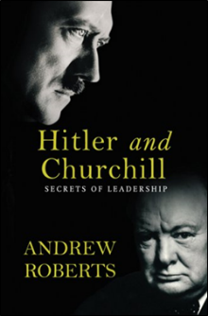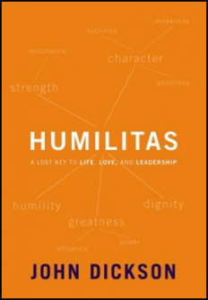

### Leading Like Jesus

In what way is Jesus a good model?

‘Against all leadership counsel we have to set Jesus, and not so much figure out how to be leaders from what he said and did but enter into the world that he lived in, the relationships that he cultivated, and assimilate his style. This leadership is not techniques and strategies culled from a superficial reading of the gospels that knows little of Jesus himself, but a Jesus-leadership spirit, mind, sensitivity. It is a leadership that is conspicuously lacking in the exercise of power and the attraction of followers.’

The Unnecessary Pastor, Eugene Peterson, p.190

What are some of the wrong ways of seeing Jesus as our model?

‘The study of Jesus does not provide us with a ‘how to’ recipe i.e. how to be a leader like Jesus. Rather we learn that Jesus in us continues to lead through us.’

Transforming Leadership, Leighton Ford, p.32

Leading like Jesus is beyond adhering to a philosophy, adopting a methodology, imitating a personality, mastering a competency, and responding to a challenge. Leading like Jesus is a life-long learning process of being formed in Christ-like character and growing in leadership ability that reflects our strengths and the needs of the community we serve.

### Christian Leadership is...

A servant oriented relationship

whereby those who lead,

under God’s leadership,

through Christ-like example,

and stewarding their God given capacity,

seek to nurture others towards

kingdom honouring attitudes and actions.

‘The most creative Christian leadership is that which is deeply rooted within the life of God.’

Elizabeth Welch

‘Despite the multitude of ways that leadership has been conceptualised, several components can be identified as central to the phenomenon of leadership. They are:

(a) Leadership is a process.

(b) Leadership involves influence. (c) Leadership occurs within a group context.

(d) Leadership involves goal attainment.’

Leadership Theory and Practice, Peter Northouse

### What to Do

Engage with what God has been saying to you today. Try to identify any areas for growth and development that you will want to consider further after the residential.

There are four options:

* **Personal reflection** You may like to journal, continue to work with some of the reflective questions used through the day, go for a walk, or use the craft materials.
* **Ask for prayer** for something that has arisen as a result of today. Mark and Jackie will be available in lounge area.
* **Discuss with others** If you process best with others stay in the Ball Room and gather with others to talk things through, or find one other person to chat with (go for a walk?).
* **Ask a question** If there is something from today that you are struggling with/would like to clarify, and it would be helpful to talk it through with James, he will be available for a chat.

You can of course do more than one of these options, but be careful not to hop between things without actually getting to grips with what God has been saying to you through the day.

#### Areas for reflection

Page 5 Biblical images for leadership.

Page 10 What is the mix of ministry and leadership in your role at this time?

Pages 12-13 What are the ‘baseline’ requirements for your role? What functions of leadership would it be helpful to exercise at this time?

Pages14-19 Strengths, gaps, limitations, weaknesses and flaws.

Page 19 Is someone other than Jesus your master?

Please be in the Garden Room at 5.45 for the final part of the day where we will gather for an experiential reflection on John 13.

‘As spiritual leaders, we must be constantly on the alert against methods, gimmicks, marketing strategies, techniques... that are manipulative methods.’

Marva Dawn

### A Prayer

Lord, you have placed me in your Church as a leader. You see how unfit I am to administer this great and difficult office. Had I previously been without help from you, I would have ruined everything long ago. Therefore I call upon you. I gladly offer my mouth and heart in your service. I would teach the people and I would continue to learn. To this end I shall meditate diligently on your word. Use me, dear Lord, as your instrument. Only do not forsake me; for if I were to continue alone, I would quickly ruin everything. Amen.

A prayer of Luther