### Why do we Need to Build Teams and Develop Leaders?

#### Wake up, now is the time!

And do this, understanding the present time: The hour has already come for you to wake up from your slumber, because our salvation is nearer now than when we first believed. The night is nearly over; the day is almost here. So let us put aside the deeds of darkness and put on the armour of light.

Romans 13:11-12

a. Part of the body.

b. It is biblical.

c. Belonging.

d. Church Growth.

e. Grasping the power of potential.

‘You date your model but you marry your mission.’

Craig Rochelle

* Equipping.

* Releasing.

* Ongoing mentoring / support / training.

* Review (or appraisal).

#### Benefits of intentionality

### Developmental Activities

Our role as ‘development leaders’ means we need to constantly be working with our ordained and lay teams to identify, preferably collaboratively, competency gaps, and support and challenge those in our teams to work on them.

Development activities are best if they're varied, motivating, and engage our team members’ learning styles.

Some development activities:

* Training.
* Briefing/explaining.
* Demonstrating.
* Coaching.
* Mentoring.
* Observing.
* Buddying.
* Shadowing.
* Reading.
* Formal education.
* Secondments/placements.
* Practice with feedback.
* Further education.

### Characteristics of Effective Teams

1. People have solid and deep trust in each other and in the team’s purpose — they feel free to express feelings and ideas
2. Everybody is working toward the same goals
3. Team members are clear on how to work together and how to accomplish tasks
4. Everyone understands both team and individual goals and knows what is expected
5. Team members actively diffuse tension and friction in a relaxed and informal atmosphere
6. The team engages in extensive discussion, and everyone gets a chance to contribute
7. Disagreement is viewed as a good thing and conflicts are managed. Criticism is constructive and is oriented toward problem solving and removing obstacles
8. The team makes decisions well, outputs are linked to agreed goals, their gatherings are structured
9. The team regularly reviews how it works together [its process] and builds in improvements

### Groups Develop into Teams

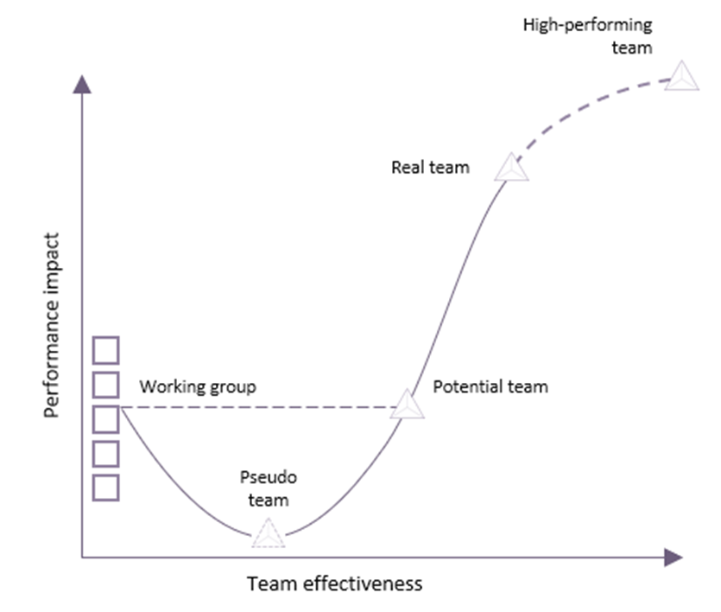

#### Team effectiveness

#### Performance impact

Working group

Pseudo   
team

Potential team

Real team

High-performing   
team

#### 1 Peter 4:8-10

Above all, keep loving one another earnestly, since love covers a multitude of sins. Show hospitality to one another without grumbling. As each has received a gift, use it to serve one another, as good stewards of God’s varied grace.

#### Hebrews 10:24-25

And let us consider how we may spur one another on toward love and good deeds, not giving up meeting together, as some are in the habit of doing, but encouraging one another—and all the more as you see the Day approaching.

#### 1 Corinthians 12:17-20

If the whole body were an eye, where would the sense of hearing be? If the whole body were an ear, where would the sense of smell be? But in fact God has placed the parts in the body, every one of them, just as he wanted them to be. If they were all one part, where would the body be? As it is, there are many parts, but one body.

#### Proverbs 27:17

As iron sharpens iron, so one person sharpens another.

#### Ecclesiastes 4:9-10

Two are better than one, because they have a good return for their labour: If either of them falls down, one can help the other up. But pity anyone who falls and has no one to help them up.

#### Superteams ➡ Kingdom Teams

### Peter Honey’s Eight Steps

1. Set your objective(s) for the session – make them challenging but achievable.
2. Agree time plan – for the entire session and/or main points.
3. Gather data/information – not opinions or suggestions (yet!).
4. Check objective is still valid – in the light of data gathered.
5. Generate ideas – no judging, evaluation, or criticising.
6. Evaluate ideas – against agreed criteria.
7. Agree action plan – who does what by when.
8. Review team process – WWW (what went well), EBI (even better if).

# EC

# TL

# DE

# CQ

### Engaged communication

#### Deep empathy

#### Constructive questioning

#### Transformational listening

|  |  |  |
| --- | --- | --- |
|  | 02Questioning Constructive questioning explores, drives deep thinking, and challenges. |  |
| 01Listening Transformational listening builds strong rapport and frees creativity. |  | 03Empathy Deep empathy uncovers the emotion behind motivations – positive or negative! |

#### Engaged Communication

### Transformational Listening

### Receiving

Information (data, facts) are received

### Mirroring

The listener mirrors the speaker(s) body language and tone of voice.

### Sensing

The listener shows they pick up the feelings of the speaker(s).

### Transforming

The listener challenges, supports and co-creates a way forward with the speaker(s)

### Transformation

© Dr Eliot Rosenbaum

### Constructive Questioning

### Open

What, why, when, how, where, who.

Tell me about… Give an example of...

### Closed

Yes/no.

Is it? Are there? Will you? Have you?

### Probing

What, why, when, how, where, who.

Follows up an open question, digs deeper.

### Leading

Shows the questioner’s thoughts, opinions, bias.

Surely the point is… don’t you think?

### Conditional

If I… will you?

If I… what will you?

If you… then I’ll...

### Build Confidence

### Signpost

Tell people what you’re going to do.

### Be Specific, Give Examples

General, vague feedback doesn’t work.

### Describe Positive Impact

On yourself, others in the team, church family, community.

### Encourage

The positive behaviour, great performance etc. to continue.

### Be Real

### Signpost

Tell people what you’re going to do.

### Be Specific, Give Examples

General, vague feedback doesn’t work.

### Describe Negative Impact

On yourself, others in the church, the community.

### Explain the Change Need

Be clear on this and how you’ll measure it.