#### cid:194F4542-BC27-4302-8D63-1920FCEDB470The story so far...

* Personal vision is about finding and fulfilling God’s call for our life, giving direction to how we use our time and talents, and invest our energy and attention.

* The PVS is a tool to help us discern more clearly God’s big yes in our lives and then live that out. It is about seeing the whole of life (not just our leadership role) as part of God’s call on us to live life the Jesus way.

* Our goal is to glorify God and be fruitful in good works through a surrendered life, leading to an abundant life, lived out in a blended life.

* We hold In tension self denial and self care.

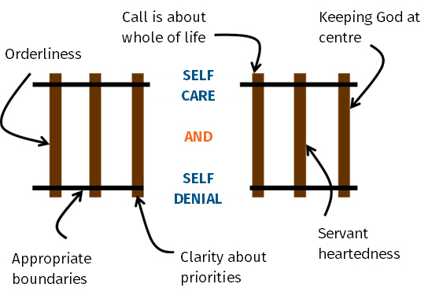

* Boundaries are important, and it helps to know where we generally locate ourselves on the boundary spectrum, and to be open to moving.

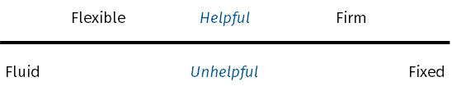

‘Being busy does not always mean real work. The object of all work is production or accomplishment and to either of these ends there must be forethought, system, planning, intelligence and honest purpose as well as perspiration. Seeming to do is not doing.’

Thomas Edison

#### STRUGGLES WE HAVE

1. Have too little time to do something.

1. Have too much to do.

1. Working inefficiently.

#### EXERCISE

If you had to identify an issue for you in personal organisation, what would it be?

### 

### 

‘For us, planned neglect will mean deliberately choosing which things we will leave undone or postpone, so that instead of being oppressed by a clutter of unfinished jobs, we think out our priorities under God and then accept without guilt or resentment the fact that much we had thought we ought to do we must leave.’

Rule of Brother Lawrence

‘Nothing else, perhaps, distinguishes effective leaders as much as their tender loving   
care of time.’

Warren Bennis

‘Time is a gift, because it is God’s time, not one’s own; and time is a friend, because there is nothing to fear from what God has in store. Time is “on our side”. One cannot buy time with God. One must learn to enjoy God’s time.’

Samuel Wells

#### Spectrum of personal organisation

### 



### Orderliness

The ordering of our lives in a way that...

glorifies God...

reflects who we are…

recognises the nature of our leadership role...

accepts our responsibilities...

embraces our season of life…

discerns God’s priorities

and increases our ability to do good works.

Almighty and everlasting God, we thank you that you have brought us safely to the beginning of this new day. Keep us from falling into sin or running into danger, order us in all our doings and guide us to do always what is right in your sight; through Jesus Christ our Lord. Amen.

Collect from Morning Prayer (Common Worship)

‘Busyness is not a problem. In anybody’s life there will be periods of intense activity. The problem comes when we are persistently over-busy. If your life doesn’t reflect the biblical pattern of activity and rest then something is wrong.’

Tim Chester

‘The overall vision the Bible gives us for productivity identifies the purpose of our productivity is to glorify God by doing good for others, the guiding principles for our productivity is putting others first, and the ultimate foundation for our productivity is the fact that God accepts us through faith in Christ, apart from our productivity.’

Matt Perman (adapted)

‘Productivity is effectively stewarding your gifts, talents, time, energy, and enthusiasm for the good of others and the glory of God.’

Tim Chlallies

‘Productivity… playful, productive momentum and control.’

Graham Allcott

#### Three understandable excuses

1. Others are better at this than me, I’ll delegate it to them.

2. My personality means that I’m not wired to be good at this.

3. I’m a creative/ideas type. Order cramps my style.

How creative are you on a scale of 1-10? ­____

How efficient are you on a scale of 1-10? ____

#### The Key

Personal Order is more than:

* Personal management.
* Time management.
* Office management.

‘Being well ordered has little to do with your personality; it has everything to do with how   
your life is structured.’

Mark Forster

‘Busyness is a subjective state, which results from the individual’s assessment of his/her own recent or expected activity patterns, in the light of current norms and expectations.’

Jonathan Gershuny

‘A zero either side means no productivity. Creativity comes mainly from questioning the problem. Efficiency comes mainly from good processes consistently applied. Productivity is a persistent and consistent interaction between creativity and efficiency.’

Mark Forster

#### EXERCISE

Think about someone you know who may be less ordered than is helpful.

* What impact does a lack of orderliness have?

* Who is most affected and why?

#### 

#### A quick questionnaire

*On your desk:*

• Do you have everything you need? Yes / No

• Does it work? Yes / No

• Can you access it easily? Yes / No

• Do you have a way of collecting everything that comes in in one place? Yes / No

*When filing (both electronic and paper):*

• Is it easy? Yes / No

• Is it fun? Yes / No

• Is it fast? Yes / No

• Can you find what you want quickly? Yes / No

*The room where you work:*

• Is the lighting great? Yes / No

• Does the environment inspire you? Yes / No

• Are you comfortable? Yes / No

• Are you relaxed? Yes / No

• Is it free of distractions? Yes / No

*When processing work:*

• Do you have a helpful way of organising everything you need to do? Yes / No

• Do you have an effective way of processing paper? Yes / No

• Do you have a way of processing your emails that ensures a zero inbox? Yes / No

• Are you known for not missing appointments? Yes / No

• Do you return calls/answer texts on time? Yes / No

• Do you have a way of arranging what to do when? Yes / No

• Do you ‘batch’ similar work? Yes / No

• Do you feel reasonably in control of your workload/flow? Yes / No

### Physical Space

* Desk.

* Décor.

#### PRINCIPLE 1. Get stuff out of your head

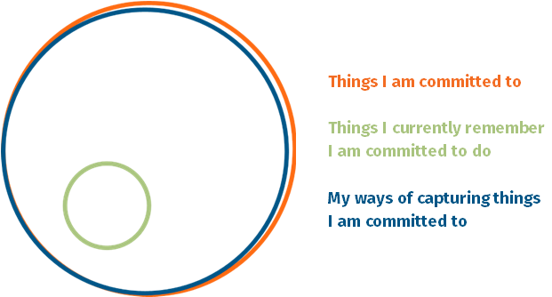

Three tools for capturing stuff:

1. Scheduling tool.

2. Task management tool.

3. Information tool.

‘Clutter and confusion are failures of design, not attributes of information.’

Edward Tufter

‘Success is rarely a matter of will power. It is more about setting up a good structure and system to support action.’

Mark Forster

‘Your mind is for having ideas, not holding ideas.’

#### PRINCIPLE 2. work in focused chunks

Create focus by:

* Getting rid of distractions.

* Working in set chunks of time i.e. 90 minutes.

* Batching. Doing like items together.

‘Our normal human tendencies are distraction and dissipation. We begin one task, then get seduced by some other option, and lose our focus. We drift away from what is difficult and we know to be true, to what is comfortable and socially condoned.’

Daniel Pinchbeck

#### PRINCIPLE 3. CREATE EFFECTIVE SYSTEMS AND MASTER THEM

Remember, there is no one way of doing this. Find a system that works for you, and master it.

### GOOD Processes or Systems

A good system will have the following characteristics (adapted from Mark Forster, Secrets of Productive People p.112):

* **Simplicity** It should be easy to use.
* **Drawing power** It should draw you into your work and help overcome procrastination and resistance.
* **Thoroughness** It should encourage work to completion.
* **Self-limiting** It should restrict you to do what can actually be done on any day. It should not result in backlogs, half done projects.

#### GuIdelines for using a diary WELL

**Use it recognising the realities of your role.**

* Plan for admin.

* Plan for interruptions.

* Plan knowing your attention flow.

* Plan for meetings.

* Plan for getting behind.

* Plan for time to pray and think.

* Plan knowing not enough time in one day to do everything, but in a week there might be.

#### 

‘People operate best from a routine not a set of lists.’

Matt Perman

‘The appointment calendar is the tool with which to get unbusy. It's a gift of the Holy Ghost (unlisted by St. Paul, but a gift nonetheless) that provides the pastor with the means to get time and acquire leisure for praying, preaching, and listening… The trick, of course, is to get to the calendar before anyone else does.’

Eugene Peterson

#### GUIDELINES for using lists well

#### 

**Types of list:**

**Check list** This is the most basic list. Anything that you do regularly that requires eye for detail, create a check list.

#### 

#### 

‘Checklists help produce the clarity that produces momentum and checklists reduce the uncertainty that causes friction.’

Graham Allcott

#### 

Then there are four levels of list one can work with.

* **Projects list** A project is any action that requires more than two steps to complete it.

* **Master actions list** Contains every single action you need to do to complete any and every project.

* **Daily to do list** What you are going to do today, ideally no more than five things.

#### 

* **Waiting for list** Tracking all the people you are waiting for to do something.

#### 

#### 

#### 

#### 

#### Guidelines for creating a good system for handling emails

Foundation Principle

A home for everything, and like goes with like!

Establish a process and action

1. Inbox

1. Bin

1. To do

1. Read

1. Waiting

1. Temporary

1. Template

When to do emails

* One a day.
* 2-3 regular times.
* Hourly dash.
* 10-90.
* Extreme.

What not to do…

Getting to zero.

‘The lack of a good filing system is one of the biggest bottlenecks in personal management.’

David Allen

‘One of the most important soft skills you can have is figuring out how to deal with a high volume of email. And the only way to do that is to put some kind of system in place that’s simple and repeatable and is going to allow you to have a life outside of email.’

Merlin Mann

‘Your inbox is not your to do list.’

Graham Allcott

‘Our normal human tendencies are distraction and dissipation. We begin one task, then get seduced by some other option, and lose our focus. We drift away from what is difficult and we know to be true, to what is comfortable and socially condoned.’

Daniel Pinchbeck

#### Guidelines for creating a good system for handling emails

Template emails

Six basic principles

1. Establish a method for processing.
2. Don’t do them all day.
3. Turn emails off in between.
4. Don’t check your emails, process them.
5. Unless pressing need, don’t do them on your phone because (a) distraction (b) inefficient © means no ‘space’ in day for boredom!
6. Avoid the temptation to cherry pick.

‘Father, give us the courage to change which must be altered, serenity to accept what cannot be helped, and the insight to know the one from other. Amen.

Reinhold Niebuhr

Other email ideas/resources

* How to Get Your Inbox to Zero Every Day, Matt Perman article.
* Do It Tomorrow and Other Secrets of Time Management, Mark Forster.
* Productivity Ninja, Graham Allcott.
* Getting Things Done: How to Achieve Stress-free Productivity, David Allen.
* Do More Better, Tim Challies. He suggests four folders: Inbox; hold for reply; archive for reference; trash for delete.

### And Finally – A Guide to Being Unproductive

* Never say no to anyone.
* Pay no attention to developing good systems.
* Start lots of things which you don’t finish.
* Do nothing to avoid distractions and interruptions.
* Avoid getting interested in what you are doing.
* Allow backlogs to build up.
* Leave stuff to the last minute and beyond.
* Think that you are naturally disorganised and there’s nothing you can do about it.
* Follow the path of least resistance – go for what is easy rather that what is essential.
* Get submerged in trivial busy work.
* Have more commitments than you have time to complete.
* Don’t ask for advice.
* Don’t identify what’s really important.
* When something goes wrong work round it instead of sorting it out.
* Make sure you forget important tasks by not writing them down.
* Take on so much work that you don’t have time to concentrate on anything.
* Keep chopping and changing your priorities so nothing gets properly developed.
* Ensure that your important work is constantly interrupted by trivial things going wrong because your low-level systems (i.e. how to handle email) don’t work properly.
* Introduce a new system at least once a year so that you never really get to grips with any system properly.
* Don’t spend time thinking about anything for too long.

This approach can be summarised under three headings:

1. Be unsystematic.
2. Overload yourself.
3. Don’t follow through.

‘The question is not whether something is high priority or low priority, but whether it should be done at all.’

Mark Twain

‘If you take on too much work, it is not some of your work that will suffer but *all* your work…. The effective person knows that to take on too much is one of the finest ways of ensuring that one is no longer effective.’

Mark Forster

‘Being productive is a learned skill, and once you have acquired it life becomes much easier.’

Mark Forster

#### The ones to read

* Do More Better, Tim Challies (Cruciform Press)
* Beyond Busyness, Stephen Cherry (Sacristy Press)
* How to be a Productivity Ninja, Graham Allcott (Icon Books)
* Time for Everything, Matt Fuller (The Good Book Company)
* What’s Best Next, Matt Perman (Zondervan)
* Andy Crouch, The Tech-Wise Family (Baker Books)
* Tony Reinke, 12 Ways Your Phone is Changing You (Crossway)

#### If you want more...

* Do It Tomorrow, Mark Forster (Hodder)
* The Busy Christians Guide to Busyness, Tim Chester (IVP)
* Secrets of Productive People, Mark Forster (Teach Yourself)
* Driven Beyond the Call of God, Pamela Evans (BRF)
* Busy Christian Living, Emma Ineson (Continuum)
* Getting Things Done, David Allen (Piatkus)
* Ordering Your Private World, Gordon Macdonald (Thomas Nelson)
* Deep Work, Cal Newport (Piatkus)
* The World Beyond Your Head – How to Flourish in an Age of Distraction, Matthew Crawford (Penguin)

#### Apps

* Todoist – across platform task management App.
* Asana – for cross team working.
* Planning Centre – for church rotas, worship, finance, people, room booking.
* Monday.com – for church management (specific version).
* Forest App – creative way of helping us leave our phones alone when we don’t want to be distracted by them.
* Pomodoro – timer Apps to use to help do focused chunks of work.

#### On procrastination

* [www.psychologytoday.com/us/basics/procrastination](http://www.psychologytoday.com/us/basics/procrastination)
* [www.mindtools.com/pages/article/newHTE_96.htm](http://www.mindtools.com/pages/article/newHTE_96.htm)
* <https://jamesclear.com/procrastination>

#### Websites

* [www.thinkproductive.co.uk](http://www.thinkproductive.co.uk)
* [www.whatsbestnext.com/resources/productivity](http://www.whatsbestnext.com/resources/productivity), includes an excellent article on getting your inbox to zero.
* [www.markforster.squarespace.com](http://www.markforster.squarespace.com)
* [www.lifehacker.co.uk](http://www.lifehacker.co.uk)
* [www.bulletjournal.com](http://www.bulletjournal.com)