### Review

The role of the leader in evangelism:

* Connect.

* Model.

* Order.

* Mobilise.

### 

### 

### 

### 

### 

### 

### 

### 

### 

### 

### 

### 

### 

### Overview of Residential 3 and 4

Four things to order and mobilise a community around evangelism:

* Shape an evangelistic culture.
* Discern an appropriate strategy.
* Equip ordinary people to play their part.
* Engage evangelists and pioneers.

‘…keep your head in all situations, endure hardship, do the work of an evangelist, discharge all the duties of your ministry.’

2 Timothy 4:5

### Mission – The Backbone of the Scriptures

#### 

#### Genesis 12:1-3 – All Peoples Blessed Through Abram

The Lord had said to Abram, ‘Go from your country, your people and your father’s household to the land I will show you. ‘I will make you into a great nation, and I will bless you; I will make your name great, and you will be a blessing. I will bless those who bless you, and whoever curses you I will curse; and all peoples on earth will be blessed through you.'

#### Exodus 19:5-6 – Israel's Calling

Now if you obey me fully and keep my covenant, then out of all nations you will be my treasured possession. Although the whole earth is mine, you will be for me a kingdom of priests and a holy nation.

#### Psalm 67:1-2 – Blessed to be a Blessing

May God be gracious to us and bless us and make his face shine on us – so that your ways may be known on earth, your salvation among all nations.

#### Isaiah 49:6 – A Light for the Nations

It is too small a thing for you to be my servant to restore the tribes of Jacob and bring back those of Israel I have kept. I will also make you a light for the Gentiles, that my salvation may reach to the ends of the earth.

#### Luke 2:29-32 – Salvation in the Sight of All People

Sovereign Lord, as you have promised, you may now dismiss your servant in peace. For my eyes have seen your salvation, which you have prepared in the sight of all nations: a light for revelation to the Gentiles, and the glory of your people Israel.’

#### Matthew 28:19-20 – The Church's Reason for Existence

Therefore go and make disciples for all nations, baptising them in the name of the Father and of the Son and of the Holy Spirit, and teaching them to obey everything I have commanded you. And surely I am with you always, to the very end of the age.

#### Acts 1:8 – Power to Get the Job Done

You will receive power when the Holy Spirit comes on you; and you will be my witnesses in Jerusalem, and in all Judea and Samaria, and to the ends of the earth.

#### Matthew 24:14 – An Achievable Task

And this gospel of the kingdom will be preached in the whole world as a testimony to all nations, and then the end will come.

#### Revelation 7:9 – The Vision Set Before Us

After this I looked and there before me was a great multitude that no one could count, from every nation, tribe, people and language, standing before the throne and before the Lamb. They were wearing white robes and were holding palm branches in their hands.

‘The study also shows that Christianity is extremely bad at either making converts or retaining cradle believers. The two big denominations, the Catholics and the Church of England, lose at least 10 members for every one they convert… “Evangelism” turns out to be a game that Christians play with each other, and not with the outside world.’

The Guardian

‘What this study reveals is that people are far more open than we might realise. After we’ve had conversations with non-Christians about Jesus, one in five of them is open to finding out more about him… So we need to talk about him: to more people, more often and more relevantly.’

Talking Jesus report

#### Exercise

What’s the brake on evangelism in your context?

#### For reflection

* Which is the main brake in your context?

* How could you release this brake?



### Starting Point

#### 

#### Church Maths

#### 

#### 

#### 

#### 

#### 

#### 

#### 

#### What it requires

* Clear thinking.

* Concerted effort.

* Enormous courage.

* Creative consistency.

‘Changing a culture requires clear thinking, concerted effort, enormous courage and creative consistency.’

Sam Chand

### What is Culture?

* Dictionary – sum of attitudes, customs and beliefs that distinguish one group from another.
* ‘Organisational culture is the personality of the church.’ (Chand)
* ‘Culture consists of group norms of behaviour and the underlying shared values that help keep those norms in place.’ (Kotter)
* ’Culture is… the basic assumptions and beliefs that are shared by members of the church and operate unconsciously, defining the church’s view of itself.’ (Schein, adapted)

Culture is how we live out our beliefs and values in our context: ‘the way we do things around here.’

### Identifying our Existing Culture

### 

### 

### 

### 

### 

### 

### 

### 

### 

### 

### 

### 

**Identify core beliefs**

Beliefs are things which we hold to be true. Form basis of things we value.

Beliefs and values influence our **assumptions** (a thing that is accepted as true or as certain to happen, often without proof) and **attitudes** (a settled way of thinking or feeling about something).

**Recognise values**

Values are key principles which act as templates and inspiration for all our actions, against which all we do is measured.

**Listen to the stories and legends that are told**

What stories do we tell? Who are the heroes? What do we look back on with fondness? What jokes are told?

**Read the symbols and rituals**

Ask yourself ‘what do we always do…’  and you are probably identifying rituals.

**Listen to language**

Language shapes culture: what words do people use when talking about evangelism, mission, discipleship?

’Words have the power to shape lives and organization – the problem is that for most of us the words that we use are second nature – they need to be examined / fashioned to produce the desired outcome’

Sam Chand

**Map the power**

What makes decisions and why? What do the structures, posts and titles say?

#### For reflection

What is the culture of your context? Use the different elements above to map it. Or alternatively use the approach on page 6.

### A Way of Mapping Culture

#### The Cultural Web

Here is one approach developed by Johnson and Scholes used in organisations to map the culture of an organisation. It is a way of seeing and understating the different influences that affect organisational culture. It can be used to map existing culture, and it can also used to map future culture based on the question: ‘what does the culture need to look like to make this change happen?’ The two maps can then be compared in order to promote discussion and highlight what, where and how change can be implemented.

Mapping culture is useful in three ways:

* **Surfacing** How and why things are done.
* **Barriers and alignment** Highlighting sticking points and supporting factors.
* **Planning changes** Planning future actions and changes.

#### Creating the Web

**The paradigm** is the core of the web, and is the core beliefs and motivations of the organisation. It is supported by the following six cultural influences.

* **Stories** How an organisation understands and explains itself.
* **Rituals and routines** The accepted norms and practices.
* **Symbols and physical artefacts** The unofficial and official representations of culture.
* **Organisational structures** Formal structures and hierarchy, as well as the  
  informal routes of power and influence.
* **Power structures** The people and the systems who have the power to get things done.
* **Control systems** How an organisation controls how things are done.

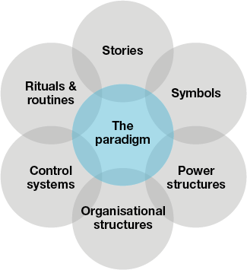

#### EXERCISE

Imagine you were visiting a church with a healthy, vibrant **evangelistic** culture, what would you observe (behaviours) against each of these areas in their services, meetings, activities?

* Core beliefs.

* Values.

* Stories and legends.

* Symbols and rituals.

* Language.

* Power.

## How to Nurture a Faith-Sharing Culture?

A faith-sharing culture is nurtured when leaders **model** in their own lives the change they want to see in others (which is why sessions 3-4 focused on this), they **work with others** to bring about the desired culture, they **teach** about the beliefs, values and practices that are at the heart of a faith sharing culture, they **reinforce that culture** through stories, celebration and embedded practices, and they **pray** throughout, because ultimately only God can bring about the change we long to see.

‘In a sense, culture-creation encapsulates what leaders need to do: it is by far the most important responsibility of leaders.’

Church leader

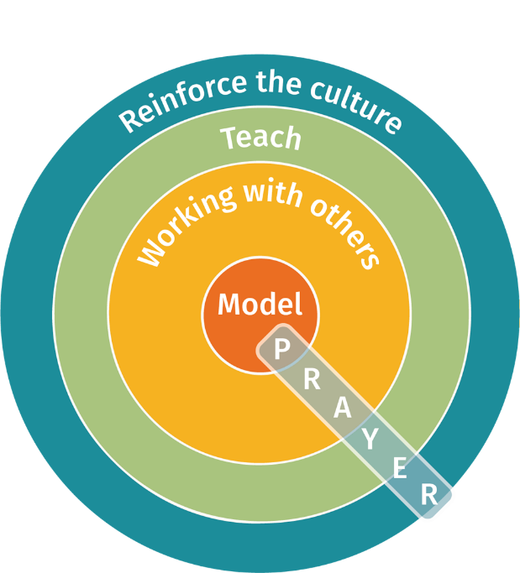

#### For more on this

Watch the video using the QR code, or read chapter 3 of How to Nurture a Faith-Sharing Culture, James Lawrence (CPAS).



#### Part 1 (15 mniutes)

As you reflect on nurturing a faith-sharing culture in your context, imagine it is the end of 2023 and you were making a video like Sue’s about how you have nurtured a faith-sharing culture in your church(es). What is the story you would tell? Capture the various aspects of your story using the different parts of the framework below.

* Model.

* Work with others.

* Teach.

* Reinforce (stories, celebration, embedded practices).

* Pray.

#### Part 2 (5 minutes)

Be ready to present your ‘story’ to your peer cell. You will have one minute 30 seconds each. Remember, you are telling a story about how you have nurtured a faith-sharing culture from now till the end of the year.

#### Reflecting on A culture of evangelism

‘A loving community committed to sharing the gospel as part of an ongoing way of life, not by the occasional evangelistic raid event.’

J.Mack Stiles

#### What might that look like?

Stiles suggests 11 characteristics of a church culture that has evangelism as an ongoing way of life – taken from Evangelism: How the Whole Church Speaks of Jesus (Crossway).

1. A culture motivated by love for Jesus and his gospel (2 Corinthians 5:14-15).
2. A culture that is confident in the gospel (Romans 1:16).
3. A culture that understands the danger of simple entertainment (Ezekiel 33:30-32).
4. A culture that sees people clearly (2 Corinthians 5:16a).
5. A culture that pulls together as one (Philippians 1:3-5).
6. A culture in which people teach one another (1 Peter 3:15b).
7. A culture that models evangelism (2 Timothy 2:2).
8. A culture in which people who are sharing their faith are celebrated (Philippians 9:19-22).
9. A culture that knows how to affirm and celebrate life (Colossians 1:3-4,7).
10. A culture doing ministry that feels risky and is dangerous (Philippians 1:12-13).
11. A culture that understands that the Church is the chosen and best method of evangelism (Acts 2:46-47).

#### For reflection

#### 

What do you make of these characteristics?

What would you add?

What might such a culture look like, sound like, feel like in your church(es)?

### Nehemiah – a Good Example

‘When I heard these things, I sat down and wept. For some days I mourned and fasted and prayed before the God of heaven.’

Nehemiah 1:4

* He prays.

* He thinks.

‘Without careful attention, faith-based organisations will inevitably drift from their founding mission. It’s that simple. It will happen.’

Peter Greer and Chris Horst

‘This is not a quick-fix strategy, but a long-term commitment to changing the story in our nation, so that people might meet Jesus, love him and follow him.’

Talking Jesus Report

#### Four questions to ask

1. Are there clear pathways that help people find faith in Christ?

2. Are decisions made favourable to evangelism?

3. Are resources allocated to further evangelism?

4. Are people equipped to engage / play their part in evangelism?

### How do people come to faith today?

#### Story Time

Think of a person who has come to faith within the last two years. What were the key stages on the path as they have come to faith in Christ? For example:

* People they met?
* Conversations they had?
* Circumstances they were going through?
* Experiences they had?
* Interactions with church/organisation?
* Background?

What can we learn from this? What is surprising, unsurprising?

### A Map



‘Many of the ‘tried-and tested’ models of evangelism have been honed on university campuses. Among students and graduates, they have proved effective. But transport these same methods to working-class and deprived areas, and you may find yourself answering questions that no one is asking.’

Tim Chester

* God is at work wherever people are on the map.

* Journey made up of appropriate next steps.

* It is normally an accompanied journey.

* It generally takes time.

* It is rarely linear.

### Growth Spiral

A suggestion of some stages in the process (cf. Keller):

* **Awareness**  ‘Oh, I see…’

* **Connection**  ‘I need this…’
* **Realisation**  ‘I need this because it’s true…’

* **Acceptance**  ‘I accept this…’

* **Reinforcement**  ‘This is what it means in my life…’

Or see Five Thresholds to Faith handout from residential 2.

### Growth spiral completeSo What is the Role of the Church?

#### Develop contacts

#### 

Raising awareness of the faith and engaging in initial contact…

* In our gathered life as church.

* In our scattered life as church, on our frontlines.

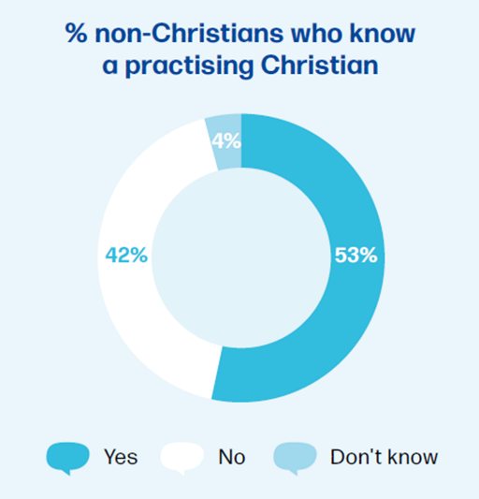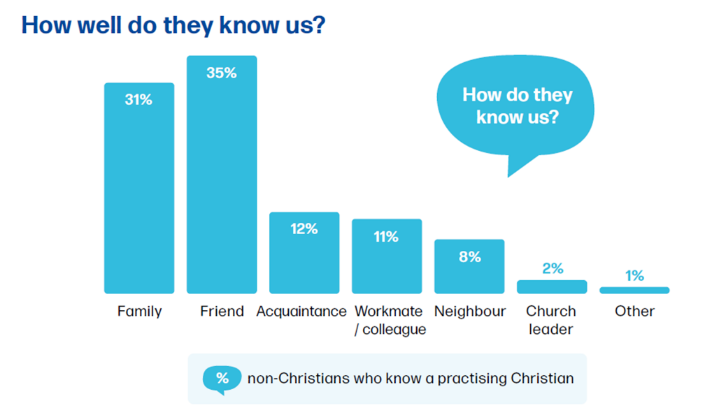

**How well do they know us?**

Majority of our contacts:

* On our frontlines.

* Uninterested in coming to church.

* Seeking to make sense of life.

* Open to a conversation about spiritual things ***if*** approached in the right way.

‘The church must change its emphasis from meeting people’s spiritual needs to stimulating their desires.’

Pete Ward

#### Nurture interest

* **Stage 1** Nurture interest through prayer, love, service, relationship, building connection with life interests and issues.

* **Stage 2** Nurture their experience of faith through 1-to-1 bible reading, nurture courses (Alpha, Christianity Explored, Start, Pilgrim), and contact with the wider church community.

#### ENCOURAGE COMMITMENT

#### 

#### 

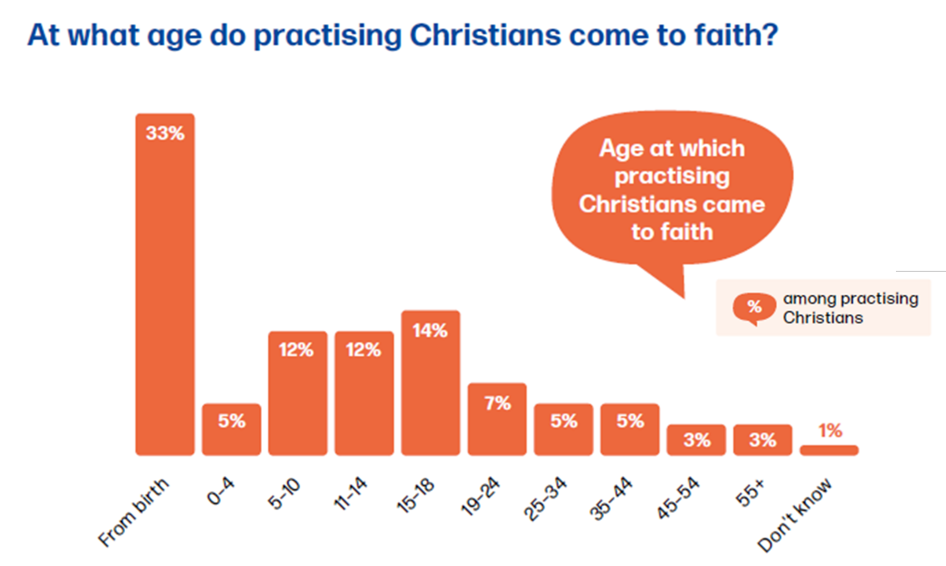

**At what age do practising Christians come to faith?**

#### 

#### 

#### 

#### 

#### 

#### 

#### 

#### 

#### 

#### 

#### 

#### 

#### 

#### 

#### 

#### 

#### 

#### 

#### 

#### Nourish growth

#### 

* **Stage 1** Early growth in faith as baptised and initiated into faith and the faith community.

* **Stage 2** Ongoing growth (normal times and when struggling), and specific growth (involved in serving/ministry).

### felipe-furtado-2zDXqgTzEFE-unsplashWhat Makes a Good Plan

* **God inspired** We’re trying to discern what God wants, which is why study of his word, prayer and fasting are so important (see Nehemiah 1).

* **Preferable future** A good plan is oriented to what might be, and inspires people to want to see that become a reality.

* **Kingdom honouring** This is so important, because sometimes a plan can be about the ego of the leader or the preferences of the congregation. Neither are appropriate. It is about what God wants, what is good for his people, and serves the community.

* **Clear and compelling** Clear so that people can understand it, they know exactly what is involved. Compelling so that people want it to happen.

* **Connected with reality** It is about an inspiring future, but it also needs to connect sufficiently with reality (our story, context and circumstances) for people to be able to see how it is possible to travel from here to there.

* **Broken down into implementable steps** With a clear and compelling destination in view, how do we actually get there? What is the next step we are going to take and how are we going to take it.?

‘Strategic planning is the work a congregation does to (1) identify the activity of God (2) make the personal and congregational adjustments needed to join in that activity.’

Herrington, Bonem and Furr

#### Common errors

Remember the three common errors when making an action plan:

1. Trying to do too much too quickly.
2. Not being clear enough about what you are actually planning to do (what you are going to do, who is going to do them, when they are to be done by).
3. Being too fixed in the plan: not being able to adjust as new things become clear, new opportunities open up, lessons are learnt from things that don’t go well.

#### When statements

A popular tool (as recommended by Chew and Ireland in their book on Mission Action Planning) is the ‘when statement’. This will happen when…

It seeks to work backwards from a desired state to identify what needs to happen before you can get to that end state. It is a helpful exercise to do with a PCC/your planning group – we will be able to get to goal X WHEN… For example...

Goal: we will attract more young families to church – **when**:

* We start a toddler group – which we will do when we find a leader; we decorate the hall; we recruit helpers; we write policy and procedures; we advertise; we talk to baptism families.
* We have monthly family service – which we will do when we have more modern worship songs; we have a kids’ worship leader; we find a suitable liturgy; we have more lay leaders.
* We improve our welcome – which we will do when we train sidespersons; we create a welcome pack; we decorate the porch; we improve the entrance lighting.
* We get advice from others – which we will do when we invite the children's’ adviser to speak to the PCC; we visit the next door parish and look at what they do.
* And so on....

### Exercise

Work on a plan for accompanying people to faith in Christ in your context.

### 

#### Options

1. Take a blank piece of paper and give it a go.
2. Use the map on page 11 as a way of thinking about where your two people you are praying for are and how you could accompany them on their journey.
3. Use the grids in the additional handouts section to plot where people are.
4. Use the following questions:

* What are the brakes on evangelism and what could release them?
* What are the opportunities you have to help people come to faith?
* What specific steps need to happen to create a clear strategy? Who would I need to involve in this?
* What action might you take next beyond this residential to move things forward?

1. Use the shifts from the book the Trellis and the Vine where they talk about vine work as the work of disciple-making and trellis work as the work of supporting the work of disciple-making. They encourage a shift from…

* Running programmes to building people.
* Running events to training people.
* Using people to growing people.
* Filling gaps to training workers.
* Solving problems to helping people make progress.
* Solo leadership to team leadership.
* Focusing on immediate pressures to long term growth.
* Focusing on trellis work to leadership.

## Every Church a Pathway to Faith

Chose four people. Ideally choose some of your Pray for Five people who live in your area, or think of other people who live in your community. Briefly describe their profile (age, life stage, occupation, connection with church, interests and so on). How could your church be a pathway to faith for them? How would thinking about this person influence what you did in services? What you prayed? What you offer the community?

How could your church be a pathway to faith for them? How would thinking about this person influence what you did in services? What you prayed? What you offer the community?

|  |  |
| --- | --- |
| Person 1 **Profile**                **Pathway** | Person 2 **Profile**                **Pathway** |
| Person 3 **Profile**                **Pathway** | Person 4 **Profile**                **Pathway** |

## Every Child a Chance to Explore Jesus

Think of all the under 18s in your context, how will they get the chance to explore Jesus? In their homes, schools and colleges, and the gathered life of the church? What might this look like?

|  |
| --- |
| In homes Resource link: [Faith at Home](https://www.churchofengland.org/our-faith/faith-home) |
| In schools Resource link: [Schools Ventures](https://www.ventures.org.uk/about-us/school-ventures) |
| Through the gathered life of the church Resource link: [Dr Sarah Holmes](https://www.youtube.com/watch?v=9A_QsUX0HDw&list=PLtGoNiFBkzgq_ZMzVhs2qSkclflRSzJo6&index=10) |

## Every Leader a Catalyst for Evangelism

Choose three leaders in your church(es), for example church wardens, elders, home group leaders, youth leaders, leader of the food bank team.

|  |
| --- |
| LEadER 1 ___________________ What would it look like for them to be a catalyst for evangelism?  How could you help them to be such a catalyst? |
| LEadER 2 ___________________ What would it look like for them to be a catalyst for evangelism?  How could you help them to be such a catalyst? |
| LEadER 3 ___________________ What would it look like for them to be a catalyst for evangelism?  How could you help them to be such a catalyst? |



Think of people you know who aren’t yet Christians, perhaps starting with the two people you are praying for. Mark where they are on the map. Which direction are they heading in? What could your church(es) put in place to accompany them on their journey to faith?

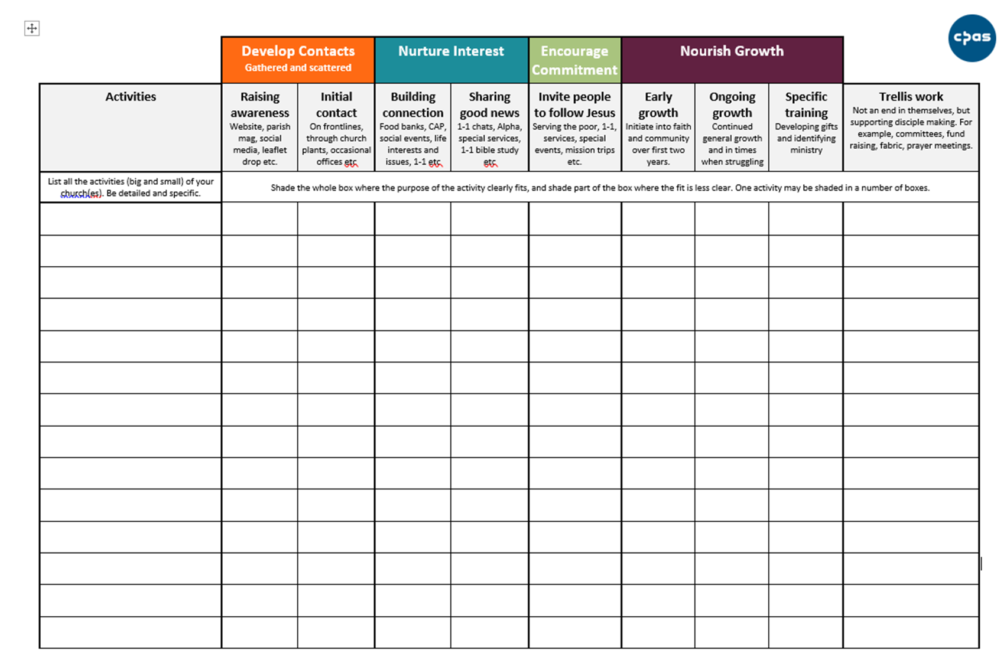

List every activity you do as a church on the separate handout. If you are in a group of churches then either:

* List activities across all the churches with a name against which church is doing that activity.
* Or do one church at a time, each on a separate sheet of paper.

Think small activities (putting information on the church notice board) as well as big (running a Messy Church), and be specific and detailed in identifying the different aspects of some activities that might do different things (i.e. a Sunday service has many aspects to it). The category at the end of the grid (Trellis work, the name comes from a book called The Trellis and the Vine) is a catch all for the activities that support the disciple-making process, just as a vine needs to be supported by a trellis in order for it to grow healthily. When you have done the mapping, reflect on:

* Where are your strengths and how could you build on those?

* Where are the gaps, and what could be done about those?