### Naming Reality

* Culture.

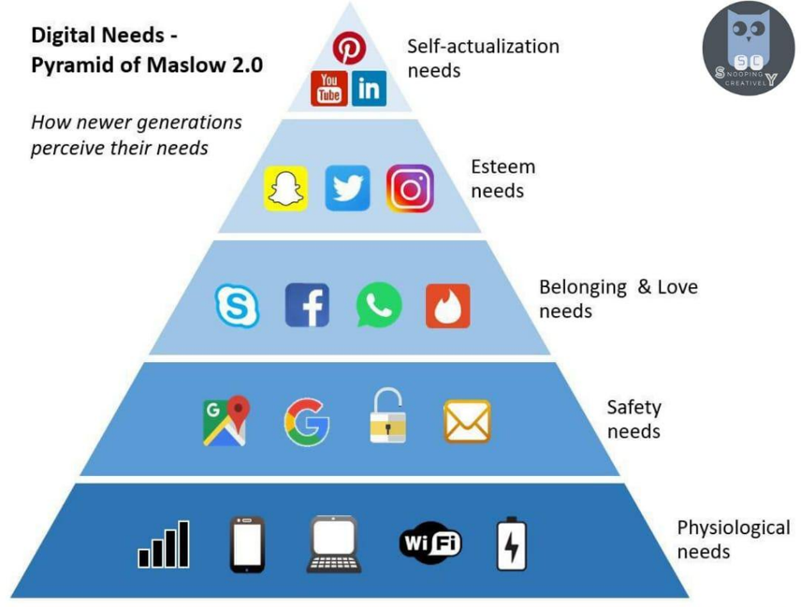

* Church.

* Personal.

‘All authority in heaven and earth has been given to me. Therefore go and make disciples of all nations, baptising them in the name of the Father and of the Son and of the Holy Spirit.’

Matthew 28:18-19

**ACTIVITY**

Where would you put yourself on each of these three continuums?



Consumption

Creation

Negatively

Positively

Not too much thought

Conviction

### Some Challenges

### 

### 

### 

### 

### 

### Some Opportunities

### 

### 

### 

### 

### 

### 

### 

### 

### 

‘50% of AI researchers believe there is a 10% chance that humans go extinct as a result of our inability to control AI.’

Centre for Humane Technology

‘Online church can and should be a tool to enhance the physical church.’

Dave Adamson

### ….Some Opportunities (cont’d)

### 

‘Google Insights reports of every month more than 30,000 search Google using the phrase ‘Church online’. This means people are actively searching the internet to connect with a community of faith.’

Nona Jones

### 

### Some Biblical Reflections

* Jesus.

‘Jesus didn’t choose to steer clear of certain places simply because there was unsavoury activity going on, and the modern day church shouldn’t either. Jesus went to those places and became a regular to teach the people there about God who wanted to connect with them.’

Dave Adamson

* Matthew 28.

* Matthew 9:37.

* Apostle Paul.

‘Much of what can be found online is complete trash – but that doesn't mean we should quit the internet altogether. It means the opposite. We need churches that are light in the darkness of the online world..’

Dave Adamson

‘Most of the way we do church flies in the face of the Apostle Paul. He was rarely in person to meet with the church communities he started and pastored. He relied heavily on the technology of his day to teach them, encourage them and stay connected with them..’

Dave Adamson

‘Jesus didn’t limit his ministry to a location or a method, and we can learn a lot from the one who started it all’

Nona Jones

### The Digital Leader

### 

### 

### 

### 

### 

### 

### The Digital Disciple

‘Although I am advocating the use of digital technology for mission and ministry, those of us who are enthusiasts for exploring new ways of communicating the gospel should bear in mind that not everyone is called to make this their primary ministry. A helpful rule of thumb to guide us in all our enthusiasms: “all may, none must, some should”.’

Pam Smith

‘I know more about what Craig Groeschel is up to than my own vicar.’

Associate pastor

‘I’ve consulted with countless denominations, local churches, and Christ centred charities, and the one thing they all have in common was a desire to grow their reach.’

Nona Jones

### The Digital Church

### 

### 

In the US, Barna research showed that at the end of 2019:

* 38% of 'practising christians' used social media to grow their faith.
* 26% accessed a sermon or message via podcast.
* 26% watched or listened to a streamed church service.

Church attendance was not decreasing before pandemic, it was decentralising’

Dave Adamson

**ACTIVITY**

Where would you put yourself/your church on the following spectrums?

**Digital in ministry is more of an afterthought than a forethought?** (Circle which one is true)

Strongly agree partially agree not sure partially disagree strongly disagree

**We have one or more stories of digital making an impact in any of the lives of individuals, our church, the community?** (Circle which one is true)

Strongly agree partially agree not sure partially disagree strongly disagree

‘We each have 168 hours in a week, but most local churches focus 90% of their resources on one or two hours on a Sunday morning, leaving people to figure out the other 166-167 hours on their own.’

Nona Jones

‘We need to move from simply sharing content to making disciples.’

Nona Jones

‘The fear that online church will replace in person church is simply not rooted in data. Research doesn’t show that people aren’t attending church because they’re watching at home.’

Nona Jones

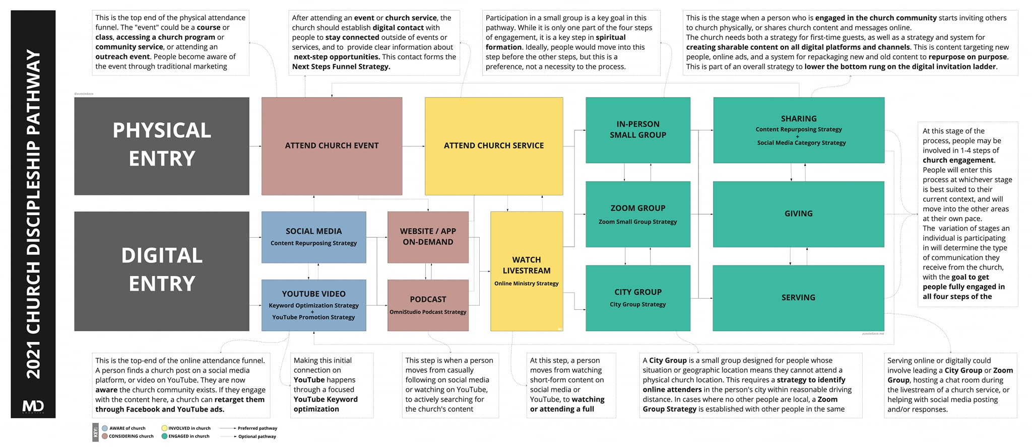

### The Message

What do you need to say?

### 

* Local mission.

* Content pillars.

* Repurpose content.

* Sustainability /consistency.

### The Market

Who do you need to reach?

‘Imagine what would happen if instead of waiting for people to find us, we went out to find them.’

Nona Jones

### The Media

Where can you find them?

### The Moment

When is it best to find them?

### The Metrics

### Platforms

* Jamboard.
* Googleclassroom.
* Slido.
* Padlet board.
* Mailchimp.
* Canva.

* A Church Near You.
* The Big 6.

‘I always say that success is about measuring against your vision and values. If your digital footprint is speaking on those, you will be about right.’

Ali Johnson

‘If your aim is to reach people then obviously, it makes sense to measure how many people are being reached… often it’s about click rates.’

Pam Smith

### A Foundational Principle

### Establishing a Process

* Organise filing.

* Processing choices.

* Delete.
* Respond.
* Diarise.
* Delegate.
* Unsubscribe.

‘Don’t skip emails and do not allow yourself to do nothing with your emails.’

James Lawrence

### When to do Emails

#### HOW TO GET TO INBOX ZERO TODAY

* Create a backlog subfolder.
* Place all your emails in the backlog subfolder. You are now at inbox zero.
* Go to the backlog folder. Arrange emails in date order starting with the oldest. Delete all email older than 3-6 months. They are six months old. There is no point in processing them.
* Count the number of emails remaining and divide by 30. This will give you how many 25 minute slots you will need to process the emails
* In your diary, place two hours to set up a method of processing emails in the next week or do it now.
* In your diary, place the number of hours required to process backlog in 25 minute slots over the next month
* In your diary, place a repeating appointment time needed to process each day.

Or...use Ai.

‘Generally, my approach is to look at them just before 9am so I can see if anyone has cancelled a meeting. I will then come back and work on them later in the afternoon once I’ve had my productive time.’

James Lawrence

### Template Emails

* Baptism enquiry.
* Wedding enquiry.
* Sunday service – who is doing what.
* Discipleship evening – reminder.
* PCC Email reminder.

**ACTIVITY**

What other template emails could you write?

 ‘A home for everything, and like goes with like’

James Lawrence

### Six Basic Principles