### Review

The role of the leader in evangelism:

* Connecting.

* Modelling.

* Ordering.

### 

### 

### 

### 

### 

### 

### 

### 

### 

### 

### 

### 

* Mobilising

⇒ Equipping ordinary people to play their part.

⇒ Engaging evangelists and pioneers.

### 

‘I think it is more helpful to think of evangelism as an art rather than as a science, being in the proper sense adaptive rather than programmatic.’

Paul Weston

**Dwelling in the Word is a process that many people are using to listen to Scripture, to each other and to God. It’s not about sharing information or seeking scholarly answers or even the right answers to the issues raised in the text, but it is about listening well to one another and discerning what God is up to amongst us.**

**We invite the Holy Spirit in prayer to open our ears, hearts and minds. We listen to the passage read out loud and notice where our attention is drawn – a verse, phrase or single word. We then remain in silence for a minute or two, staying with the place in the passage that stood out for us.**

#### Luke 10:1–12

1 After this the Lord appointed seventy others and sent them on ahead of him in pairs to every town and place where he himself intended to go. 2 He said to them, “The harvest is plentiful, but the labourers are few; therefore ask the Lord of the harvest to send out labourers into his harvest. 3 Go on your way. See, I am sending you out like lambs into the midst of wolves.

4 Carry no purse, no bag, no sandals; and greet no one on the road.

5 Whatever house you enter, first say, ‘Peace to this house!’ 6 And if anyone is there who shares in peace your peace will rest on that person; but if not, it will return to you. 7 Remain in the same house, eating and drinking whatever they provide, for the labourer deserves to be paid. Do not move about from house to house. 8 Whenever you enter a town and its people welcome you, eat what is set before you; 9 cure the sick who are there, and say to them, ‘The kingdom of God has come near to you.’ 10 But whenever you enter a town and they do not welcome you, go out into its streets and say, 11 ‘Even the dust of your town that clings to our feet, we wipe off in protest against you. Yet know this: the kingdom of God has come near.’ 12 I tell you, on that day it will be more tolerable for Sodom than for that town.”

|  |  |
| --- | --- |
| 1 | We each turn to a person in our group. If there is someone you don’t know so well engage with them. |
| 2 | We listen to that person as he or she says what they heard in the passage in a particular verse, phrase or even single word. They may mention something they’d never heard before, something odd or something comforting, or something about which they’d like to find out more about. |
| 3 | Listen well, because your job will be to report to the rest of your group what your partner has said, not what you yourself said. Some people even take notes to help them focus and remember. If you don’t yet know each other well, introduce your partner by name to the group and then share what you heard them say. Each one takes their turn when they are ready to speak. |
| 4 | If there is time a conversation develops around what God is saying to us today from the themes arising in the whole group. It can be helpful for the group co-ordinator to keep a brief note of themes and insights that arise. |

Adapted from Church Innovations (www.churchinnovations.org)

**Dwelling in the Word. So that the Word dwells in us.**

### Evangelism as a Body Ministry

‘Everyone has a part to play and we need everyone to play their part.’

We long for people to share their faith in a…

* Relaxed...

* Natural...

* • Helpful...

... way, so that they might be courageous witnesses in daily life.

#### Why courageous and not confident or competent?

*(Although of course we do long for them to be competent and confident as well.)*

1. Consider what the early Church prayed for in Acts 4:29, then see Acts 4:31, 9:28, 13:46, 18:26, 19:8, 28:31.

1. Recognise it is hard to feel confident when:

* Facing persecution or ridicule.
* In the complexities of the contemporary world.
* When you’ve just become a Christian.

1. Confidence is a rather professional, middle class concept.

‘I learned that courage was not the absence of fear, but the triumph over it. The brave person is not the one who does not feel afraid, but the one who conquers that fear.’

Nelson Mandela

For further exploration on the difference between [evangelism, witness and evangelist](https://www.cpas.org.uk/sites/default/files/content/CPAS%20-%20Leading%20in%20Evangelism%202%20-%20Typology%20of%20Terms.pdf).

‘Nothing is more deadly than a Christian who is indifferent to the salvation of others. Indeed I wonder if such a person can be a true Christian.’

John Chrysostom

Devote yourselves to prayer, being watchful and thankful. And pray for us, too, that God may open a door for our message, so that we may proclaim the mystery of Christ, for which I am in chains. Pray that I may proclaim it clearly, as I should. Be wise in the way you act towards outsiders; make the most of every opportunity. Let your conversation be always full of grace, seasoned with salt, so that you may know how to answer everyone.

Colossians 4:2-6

### 1. Agree Expectations

Unrealistic expectations demotivate people. Unclear expectations confuse people.

What are the baseline requirements for everyone?

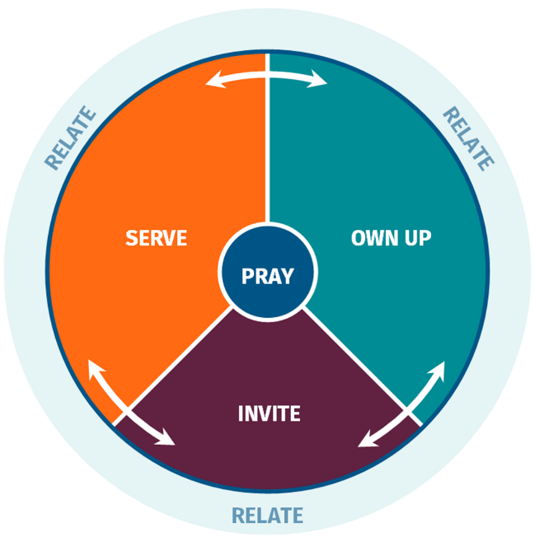

Don’t assume people know what is expected of them.

Don’t assume you know the expectations people have of themselves.

For some ideas on [increased expectations](https://www.cpas.org.uk/sites/default/files/content/CPAS%20-%20Different%20expectations%20in%20evangelism.pdf) as people mature in faith, identify gifting and take on responsibility.

### 2. Be Frontline Focused

Most people’s frontlines are made up of:

* Occupation.
* Neighbourhood.
* Networks.
* Home.

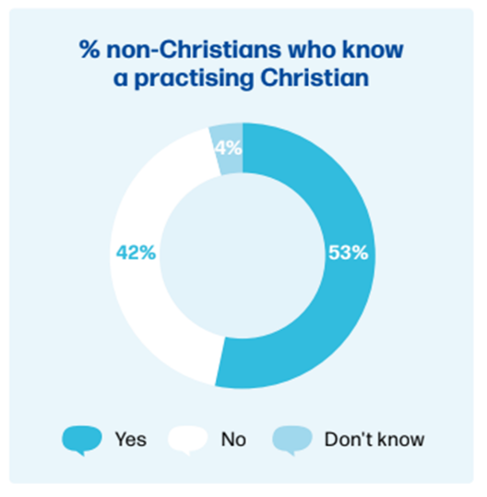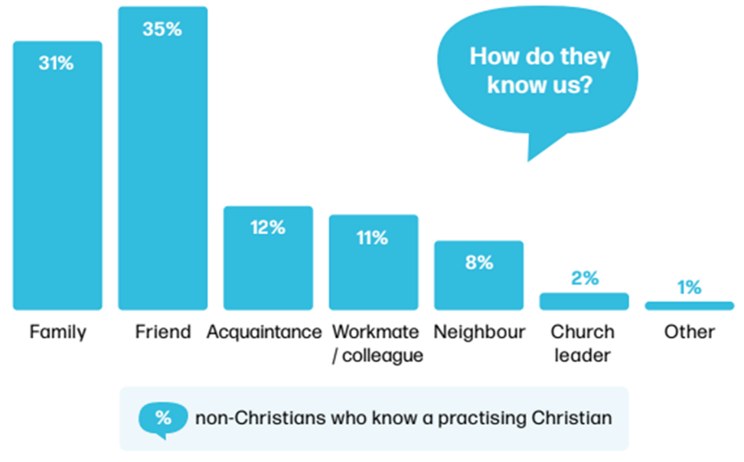

Source: Talk Calling 2022

LICC have some great resource for thinking about Frontlines, including their [Frontline Sundays materials](https://licc.org.uk/ourresources/frontlinesundays/).

#### Multi-faceted households

* Those living alone in house.

* Those living with others/in community.

* Those living with spouse.

* Those living with spouse and children.

‘Household evangelism is about how we can use our homes to be places where the good news about Jesus is shared, is evident.’

Becky Widdows

#### Research on families

(see Faith in Our Families)

#### 

* 41% of practicing Christian attribute their faith to growing up in a Christian home (Talk Calling).
* 28% of church attending Christians report they do not mind whether or not children share their beliefs.
* Among Anglicans who say that religion is very important in their lives, only 36% listed religious faith as especially important quality that children can be encouraged to learn at home, compared to good manners 94%.
* Only around 50% of children brought up in Christian homes still follow the faith as adults.
* 36% of parents surveyed felt very confident in nurturing their child’s faith, whereas 26% felt less confident. How confident a parent felt had a significant relationship to their views on nurturing faith and what they currently do at home.

The key factors that increase the chances of children choosing to follow their parents’ faith are:

* Children feel close to their parents and grow up in a warm family.
* Children see that their parents have a developing, authentic (not perfect) faith themselves.
* Parents seek to develop and nurture their children’s faith.
* Children receive positive multi-generational input from the wider family and church.

#### vision





#### ACTIVITY

What would this look like in your household? Try to identify five simple ideas.

#### For Reflection

How could you teach this to others in your context?

### 3. Start Small to Gather Momentum

Suggestions:

* Give them a [prayer to pray](https://www.cpas.org.uk/sites/default/files/content/CPAS%20-%20Prayer%20and%20evangelism.pdf) as part of their daily prayers.
* Suggest they say ‘God bless you.’
* Each sermon, include a section on ‘If talking to someone about your faith this is what it might look like…’

#### ACTIVITY

What other ideas do you have for starting small?

#### For reflection

Which starting small ideas would work best in your context?

Which one are you going to start with?

How will you best do that?

### 4. Offer Just-in-time Training

#### Think twice before running a course

Courses tend to be attended by:

* Those who like courses.

* Those who least need them.

* Those who have the time.

Courses tend to front load input and offer minimal ongoing support.

Some evangelism training courses suffer from ‘gift projection’.

#### Provide just-in-time training

* Share a guide on [how to invite people](https://www.cpas.org.uk/sites/default/files/content/CPAS%20-%20How%20to%20invite%20people%20to%20an%20event.pdf) to an event, especially when you have a suitable event coming up.
* Send a link to an online video people can watch e.g. [how to talk about your faith with someone who is apathetic](https://www.walesleadershipforum.org.uk/wlf_video/share-gospel-people-apathetic/).
* Run a 20 minute Zoom session on a relevant topic e.g. how to make the most of the Easter season. How to talk about the recent census figures. How to talk about LLF.
* In existing small groups take a common scenario and talk about how you would engage with it.
* A family member shares they are going through a hard time: how to offer to pray with or for them.
* A colleague asks what you got up to over the weekend: how to own up that you go to church.
* A neighbour comments that they wish they had your faith: how to respond and perhaps invite someone to read a booklet, watch a video, or come to an event.
* An online contact notices you have made a change in your online posts (since becoming a Christian, although they don’t know that is the reason why): how to speak of the difference Christianity has made in your life.
* At a social event a person you’ve just met asks ‘what do you do?’
* A friend who is a parent and who brings their child to a parade service once a month: ‘It’s good for her to learn about right and wrong….’
* At a school governor’s meeting, over coffee someone says to you: ‘Why is the church so homophobic?’
* Travelling on a train reading a Christian book or Bible someone sits across from you and makes conversation: ‘We buried my niece last week, she was only 14.’
* A friend admits they are really struggling with anxiety. How do you respond?
* A co-worker mentions the horrors of the war in Ukraine ‘How can people do that to other people.’
* A contact on social media comments about a religious item on the news by dismissing the Christian faith: how do you respond?
* A family member is surprised to hear that you go to church.

* Run a 45 minute session on one of the common things that hold people back from sharing their faith. [The Evangelism Health Check Tool](https://healthcheck.talkingjesus.org/) is a great way to discover what does hold people back (use the 10 question version). Alternatively create a [simple questionnaire](https://forms.gle/s264GxXHVYgkH6QG6) and send it round your people.

#### ACTIVITY

Create an approach to equipping people to share their faith in your context from September 2023 to December 2024. Take into account the ‘brakes’ we identified last time, and the various resources available today.

### 1. Identify

If you had to name two people in your church(es) as possible evangelists who would they be?

**Possible evangelist**

Why I think they may be an evangelist...

**Possible evangelist**

Why I think they may be an evangelist...

If you had to name two people in your church(es) as possible pioneers who would they be?

**Possible pioneer**

Why I think they may be a pioneer...

**Possible pioneer**

Why I think they may be a pioneer...



### Pioneers

A definition of a pioneer: a person called by God who has the character and gifting to respond first to the Holy Spirit’s initiatives within a particular context and to create with others something in response to these promptings that opens up new horizons.

#### Pioneer Spectrum

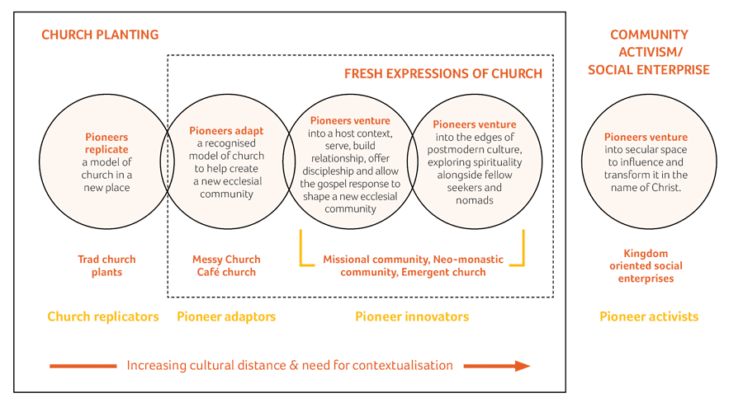

‘Pioneering leadership is so important for the future of the Church. We can no longer afford for most of our leaders, both lay and ordained, to be trained, equipped, formed and deployed to continue leading in the way leadership has operated over the last few hundred years.’

Dave Male

#### Common Traits

Dave Male identifies ten common traits in his Grove book Pioneering Leadership, and stresses most won’t have all these qualities, but are likely to exhibit many.

1. They are people who are first and they love firsts.
2. They are on the edge. They feel more at home on the borders.
3. They enjoy taking risks.
4. They like people. They like to build community.
5. They are robust characters with the ability to respond to their calling in a particular context even when it seems crazy to do it.
6. They know when to stay or go.
7. They know when to bring order or chaos.
8. They are often thinking about moving out, pushing boundaries.
9. They are dissenters. They often ask difficult questions.
10. They are able to reflect, connect and not know. They don’t have to have all the answers, are happy to ask questions.

#### Evangelist in the New Testament

* Acts 21:8 Philip the evangelist.

* Ephesians 4:11-13 evangelists given to ‘equip the people for works of service.’

* 2 Timothy 4:5 ‘do the work of an evangelist.’

‘The evangelist is a gift ministry… however, there is nothing in the New Testament that declares the evangelists are only meant to operate in particular ways, or for that matter on a particular scale. There have been many truly gifted evangelists over the years that nobody has heard of, and who have never filled a church hall let alone a stadium.’

Gavin Reid

#### Definition

#### 

‘The evangelist is someone whom God gifts in a special way in evangelism to (a) help the Church be all that it is meant to be by modelling, inspiring and training the people of God in evangelism (b) be particularly fruitful in connecting with those outside the Church and drawing them into a life transforming relationship with Jesus.‘

Anglican Evangelists

#### QUALITIES

1. Called and gifted by God.
2. Concern for people outside of Church.
3. Able to connect faith and people’s lives together in a way that makes sense to the non Christian.
4. Able to explain aspects of the gospel.
5. Able to help people take their next appropriate step.
6. Equips people of God to play their part as witnesses.
7. Indebtedness to the grace of God.

Based on work by Mark Brown, and written up in an [evangelist gift inventory](https://www.cpas.org.uk/sites/default/files/content/LELH%20S8%20-%20Evangelists%20inventory.pdf), a guide to help people discern if they are an evangelist.

‘Unless and until the Church identifies and trains evangelists both for the work of evangelism and for the work of equipping all God’s people in their witness, we will struggle to get beyond the guilt inducing patterns of the past.’

Bishop Martyn Snow

#### 1. Evangelists are people who are difficult and uncooperative

They are lone rangers who brook no authority and 'do their own thing'. There is an element of truth in this — as can be seen in the definition in paragraph 4.3, part of the ministry of an evangelist is to challenge the Church. The evangelist proclaims the gospel, and that is always uncomfortable. He or she also seeks to interpret the world to the Church, and often the Church finds that daunting, as it is faced by the realities of the context in which it is set. But that is precisely why the Church needs the evangelist — as a spur to the Church to lift its eyes off its own concerns. Not surprisingly, evangelists sometimes feel that the Church is not listening. We found diocesan evangelists longed to be accepted and used by the Church and to receive any support and training that was offered.

#### 2. All evangelists are evangelicals

As a matter of fact we found that this was simply not true. All traditions within the Church were well represented in the people we met.

#### 3. Evangelists are preachers

In communicating the gospel many different means are used, and preaching is one that is God-given. A comparatively small number of the evangelists we met saw themselves as preachers: most of them were visiting, leading groups, encouraging the young, praying and sitting alongside people.

#### 4. Evangelists travel

The image is of someone who is footloose and rootless. Those diocesan evangelists who had a ministry across their diocese were naturally not in their church every Sunday, but we found a deep desire by the great majority of evangelists to be part of a church that would accept and support their ministry and from which they could feed.

#### 5. Evangelists knock on doors or preach on street corners and embarrass people

The ministries of the evangelists we met seldom involved the first and never the second. Most ministered through friendship and Christian nurture, through church planting and initiating work among the sick and the homeless, the young and those outside the Church.

Only as the Church rids itself of these inaccurate pictures can it fully use the ministry that is vital to its wellbeing.

### Selection of Evangelists

The areas that need to be borne in mind during any selection process for an evangelist are:

* A spiritual life founded upon a real experience of Christ in their lives, both in the past and in the present — this should be evidenced by regular spiritual discipline and study of the scriptures.
* An enthusiasm for passing on the good news to others alongside a love and respect for people.
* A wish to be rooted in the local church even if God is calling him or her to a more itinerant ministry — this should be shown in an active life within a local church and a willingness to work with others under leadership.
* Some understanding of the way in which the gospel relates to their own context at work and at home, and the ethical issues that arise.
* A warm and relaxed personality allied to a sense of humour. They should have shown themselves to be flexible in their approach to a wide variety of people and situations, and to have an understanding of failure in themselves and in others.

From Good News People, Recognising Diocesan Evangelists, Church of England Report Misc GS565 (1999).

### 2. Resource

**ACTIVITY**

How do you resource someone who is a possible evangelist or pioneer if you are not either of these   
things yourself?

#### Resource links for pioneers

**Fresh Expressions**

* [**Playfully Serious**](https://churcharmy.org/our-work/research/recently-completed-research/playfully-serious/?authuser=0) A Church Army research report on the impact of Messy Church showing there is much to celebrate and learn. There is a summary document, video and longer papers.
* [**Day of Small Things**](https://churcharmy.org/our-work/research/publications/?authuser=0#fresh-expressions-of-church-reports)A Church Army research project into Fresh Expressions of Church (2016). This and other research papers, including a helpful four page summary of all their research into Fresh Expressions, can be freely downloaded.
* [**Reaching New People**](https://www.stalbans.anglican.org/rnp/stories/?authuser=0) is a project in St Albans Diocese and they have a range of stories of the different ways churches are reaching new people.
* [**Fresh Expressions website**](https://freshexpressions.org.uk/?authuser=0) Loads of great resources on here, including The Mission Shaped Introduction and Mission Shaped Ministry courses, fascinating stories of how fxC have started, the core values and an outline journey for a fxC.
* [**Fresh Expressions Fruitfulness Framework**](https://www.eidoresearch.com/fruitfulness-framework?authuser=0)A resource to help you measure the impact your Fresh Expression is having on those who attend across five areas.

**Church Planting**

* [**CCX**](https://ccx.org.uk/?authuser=0)Centre for Church Multiplication offers a range of courses and resources on their website.
* [**Myriad**](https://ccx.org.uk/myriad/?authuser=0) is a movement training up lay church planters.
* [**Church Planting Pathway**](https://www.stewardship.org.uk/church-planting-pathway?authuser=0)Stewardship run a consultancy service to help church planters in their early stages of setting out and setting up.

**Pioneers**

* [**Church Army research on Paid Pioneers**](https://churcharmy.org/wp-content/uploads/2022/06/paid-pioneers-summary-report-digital-2022-06-01.pdf?authuser=0) contains some really helpful key messages for the wider church (page 10), which can be read in the summary of the report or watched in [a short video](https://www.youtube.com/watch?v=V0fK5NRFEZM&authuser=0) (0.44).
* [**Pioneer Spectrum**](https://pioneer.churchmissionsociety.org/pioneer-spectrum/?authuser=0) A range of resources to help you reflect on different types of pioneers, including a guidebook, card game, and discussion materials.
* [**Pioneer FAQs**](https://pioneer.churchmissionsociety.org/about/what-is-pioneering-pioneer-ministry-faq/?authuser=0) CMS address a range of FAQs on their website about pioneers and pioneering.
* [**How to Pioneer**](https://www.chpublishing.co.uk/books/9781781401262/how-to-pioneer-the-course-single-copy?authuser=0) A book and course by Dave Male from CHP.

#### Resource links for evangelists

#### 

* [**The Disappearing Evangelist**](https://vimeo.com/418427115) In this video Steve Chong proposes seven types of evangelists that will help the ministry of the evangelist flourish in the next decade. (You will need to log in to a Vimeo account, but worth the effort!)
* [**Difference between pioneer and evangelist**](https://www.bathandwells.org.uk/ministry/exploring-ministries/is-god-calling-me-to-be-an-evangelist/what-is-the-difference-between-a-pioneer-and-an-evangelist.php) Interesting article from Bath and Wells diocese on the difference between a pioneer and an evangelist.
* Evangelists - a Gift to the Church A free download from CPAS on the role of the evangelist.
* [**Evangelist Inventory**](https://www.cpas.org.uk/sites/default/files/content/LELH%20S8%20-%20Evangelists%20inventory.pdf) A free download from CPAS to help you discern if you are an evangelist.
* [**The College of Evangelists**](https://archbishopsevangelists.org/) The Church of England is committed to nurturing evangelists through the College.
* [**The Evangelists Conference**](https://evangelistsconference.com) Run each year in January, you can listen to the talks from the previous conference [here](https://evangelistsconference.com/2023-talks/).
* [**Church Army**](https://churcharmy.org/) The officially recognised body for training Anglican evangelists in the UK and Ireland.
* [**Counties**](https://www.counties-training.org/etp) run an evangelists training programme, as do [**New Wine Ireland**](https://www.newwineireland.org/evangelist-training-course).
* [**Amplify**](https://www.amplifyacademy.co.uk/) is a six month long evangelist training academy for 11-17 year olds run jointly by a number of organisations.

### 3. Release

#### Some do’s and don’ts

**Don’t** tie them up with too much church stuff.

**Do** get them involved in shaping the life of the church.

**Don’t** let them become isolated.

**Do** ask them to mentor others.

**Don’t** be quick to take offense.

**Do** work on any abrasive edges.

**Don’t** be too quick to use them to train Christians in faith sharing.

**Do** help them understand gift projection.

This is a great post on [how to spot an immature evangelist](https://thev3movement.org/2016/04/13/how-to-spot-an-immature-evangelist/) and what to do about it.

‘The best decision anyone can ever make, at any point in life, in any circumstances, whoever they are, wherever they are, whatever they are, is to become a disciple of Jesus Christ. There is no greater decision for a human being in this life, any human being.’

Justin Welby

‘I would suggest to you the purest motivation for evangelism is vision. Vision means to see the world and all the people in it as God the Father sees them.’

Leighton Ford

### Evangelists in Your Context

#### 

#### instructions

Look back at your names on page 11 (identifying possible evangelists). Any changes or additions you want to make?

Share your names with others in leadership, and see if you come up with an agreed list of possible people and write them in the identify row below. Then capture any immediate thoughts on how to resource and release them.

|  |  |
| --- | --- |
|  | Evangelists |
| **Identify**: possible people |  |
| **Resource**: what could you do as a church to nurture these people in their gifts? |  |
| **Release**: what could you do to give them opportunities to exercise their gifts? |  |

### Pioneers in Your Context

#### instructions

Look back at your names on page 11 (identifying possible pioneers). Any changes or additions you want to make?

Share your names with others in leadership, and see if you come up with an agreed list of possible people and write them in the identify row below. Then capture any immediate thoughts on how to resource and release them.

|  |  |
| --- | --- |
|  | pioneers |
| **Identify**: possible people |  |
| **Resource**: what could you do as a church to nurture these people in their gifts? |  |
| **Release**: what could you do to give them opportunities to exercise their gifts? |  |