### The Leadership Track

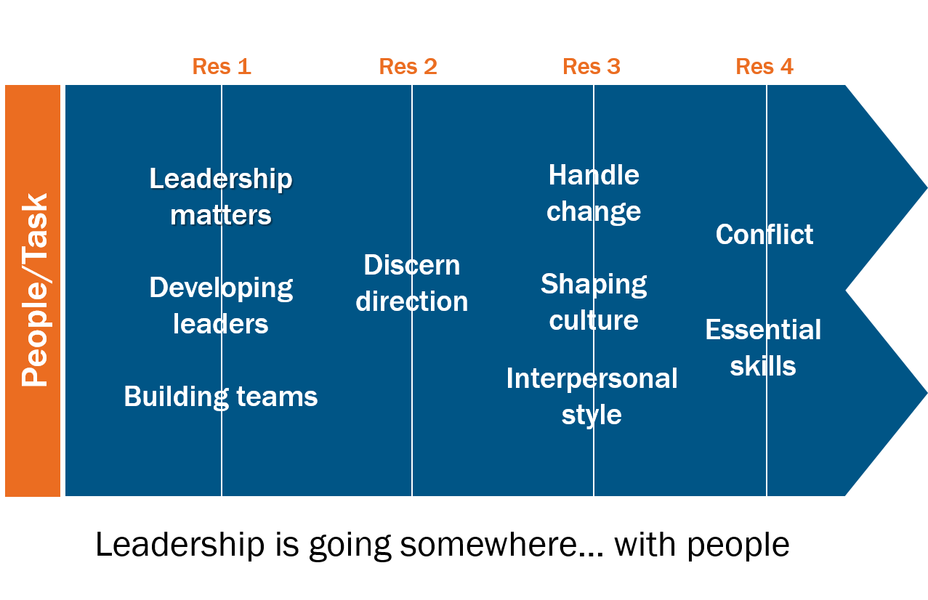

 Pay close attention to yourself and to your teaching; continue in these things, for in doing this you will save both yourself and your hearers.

1 Timothy 4:16

|  |  |  |
| --- | --- | --- |
| Inner life  * Relationship with Christ * Character * Vocation * Emotional intelligence * Resilience |  | Outer life  * Relationship with others * Competencies * Responsibilities * Emotional intelligence |

 

### Always True of Leadership

* Leadership is complex.

‘Leadership is ultimately a mystery which no one fully understands.’

John Adair

In pairs complete the following sentence as many times as you can in five minutes, and choose one each to write up in large letters on an A4 sheet of paper using a marker pen to ‘display’ when we gather back.

Leadership is more ______________ than ________________

* Leadership is messy.

‘True leadership is difficult and complex. The exercise of leadership will stretch us and test us to the limits of what we can bear.’

Steve Croft

### Specific to Leading at This Time

#### ThE global situation

### VUCA-G World

V

U

C

A

G

Or perhaps a BANI (Brittle, Anxious, Non-linear, Incomprehensible) world, see What BANI Really Means (forbes.com) at <https://shorturl.at/owzE6>.

#### Predictable behaviours in neutral space

* Anxiety rises/motivation falls.
* Attendance drops off.

* Old weaknesses/conflicts re-emerge.

* Leaders overloaded.

* People polarised.

#### For reflection

What have you learnt about leadership over the last three years?

Where has 2020-2024 left you as you enter Arrow?

‘The Judaeo-Christian tradition provides the longest continuous source of reflection on questions of leadership in the whole of human history.’

Steve Croft



#### Suspicion is Healthy

The use of ‘archon’ in the New Testament:

* Roman authorities (Romans 13:3, Acts 16:19).

* Jewish leaders (Acts 23:5).

* The prince of demons (Matthew 9:34).

‘Not so with you…’ (Mark 10:41-44).

### 

### 

#### Rejection is unhelpful

#### An Activity

Define the characteristics of Christian leadership from engagement with the Scriptures. Select four to write up on your flipchart paper.

### Image One – Shepherds of God’s Flock

#### Ezekiel 34:1-10

* What are the characteristics of the bad shepherds?
* In what ways have you seen leaders using their leadership role to meet their own needs? (Jude 12)

#### John 10:11-18

* What are the characteristics of the good (word used here doesn’t mean morally good, but skilled, proficient, able) shepherd?
* How might these impact your own leadership?

#### 1 Peter 5:1-4

* How does this passage shape our understanding of being under-shepherds?

### j0422656Image Two – Steward of All that God Gives

#### Matthew 25:14-40

* What do we learn from this passage about the stewardship of God-given talents?
* Who have you seen steward their God-given talents well? What did they do?
* What prevents you from stewarding your God-given talents well?

### Image Three – Servants of the King

#### Matthew 20:17-28

* What insights do we gain from this passage on ‘servant leadership’?
* What does and doesn’t it mean to be a servant leader?

#### Philippians 2:1-11

* How does this passage inform our understanding of servanthood as modelled by Jesus?

### 1384593913951392427Bible Words for Leadership

Below are a variety of words associated with those exercising leadership roles within the New Testament.

#### Doulos – Slave

‘Paul a doulos of Jesus Christ’ (slave, not servant) – Romans 1:1; Philippians 2:7.

### 

#### Diakonon – Servant

‘I am among you as the one serving’ – Luke 22:24-27; Acts 21:19.

#### Kyberneseis – Pilot

‘And God placed some to be… governings…’ (‘pilot’ or ‘helmsman’ not administrator. Kyberneseis used in Acts 27:11 and Revelation 18:17 in ordinary sense of pilot. Word was used by Greeks to speak of the art of government, guiding the ship of the state.) – 1 Corinthians 12:28.

#### Huperetes – Under rower

‘For I appeared to appoint you as an attendant (an ‘under rower’, a subordinate acting under another’s direction) and a witness’ – Acts 26:16, 1 Corinthians 4:1.

#### Leitourgos – Minister

‘Because of the grace given me by God to be a minister’ (used in Greek to describe a public servant or minister in a representative role) – Romans 15:16.

#### Episcope – Overseer

‘Keep watch over yourselves and over all the flock, of which the Holy Spirit has made you overseers, to shepherd the church of God…’ – Acts 20:26, Titus 1:7-9, 1 Timothy 3:1-7.

#### Presbyter – Elder

‘And when they had appointed elders for them in every church…’ – Acts 14:23.

#### Hegemenon – Leaders

‘Remember your leaders (guides, only used here in the New Testament) who spoke to you the word of God, consider the outcome of their life…’ – Hebrews 13:7.

#### Architekton – Expert Builder

‘According to the grace given to me, I laid the foundation as a wise expert builder…’ – 1 Corinthians 3:10,   
Ephesians 4:11-16.

#### Proistemi – Lead

‘Having gifts that differ according to the grace given us; let us use them… the one taking the lead (literally to stand before, to lead, to attend to, indicating care and diligence) in diligence…’ – Romans 12:8, 1 Timothy 3:4.

#### Sunergo – Co-Workers

‘For we are fellow workers for God…’ – 1 Corinthians 3:9, Romans 16:3.

#### What others have to say

‘From the perspective of the Christian tradition, the exercise of church leadership is primarily about character and virtue and integrity before it is about skills, knowledge or proficiency. This is not say that such skills are unimportant, simply that personal qualities take priority.’

Steve Croft

‘Leadership is a relational process of social influence through which people are inspired, enabled and mobilised to act in positive, new ways, towards the achievement of God’s purposes.’

Understanding Christian Leadership, Ian Parkinson

‘Leading yourself is largely about living a rhythm of life that renews the life of God within us.’

Nancy Ortberg

‘When we consider responsible stewardship of our talents, we are likely to serve him more effectively by investing that which God has planted in us… rather than by trying to force in that which he did not put there in the first place.’

Jonathan Frank

‘Sometimes the use of this servant concept has resulted in an abdication of leadership, particularly when it was mistakenly understood to imply that the servant's primary role was to meet the demands of those he or she was called to serve. This is a serious misunderstanding of the servant role of Jesus, who was first and foremost the servant of his heavenly father.’

Eddie Gibbs

‘Servant leadership is community directed. It uses power for the growth of those who are being led and the accomplishment of the shared mission of the community.’

Walter Wright

‘Servant leadership is not an impossible ideal in our day. Rather it should be the foundational cornerstone of our thinking about spiritual leadership. Christ lived, taught, and modelled it for us, and it is our true distinctive as believers.’

Stacey Rhinehart

### MP900405396[1]The Difference Between Ministry and Leadership

Write down everything you have done in your working life over this last week.

#### Ephesians 4:7-16

### Definitions

* **Ministry** is any activity which serves the needs of people.

* **Leadership** is any activity which directs, influences or facilitates ministry by others.

#### 0 20 70 150

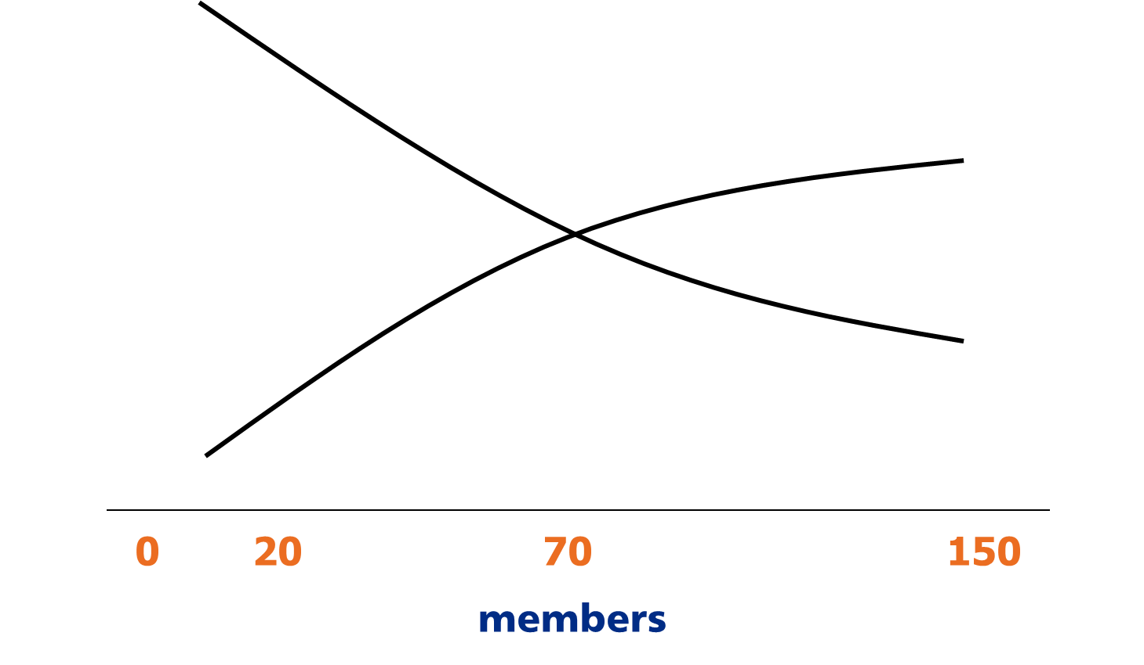

From Empowering Church,Ian Jagleman

‘As spiritual leaders, we must be constantly on the alert against methods, gimmicks, marketing strategies, techniques... that are manipulative methods.’

Marva Dawn

#### For reflection

Reflecting on your mix of ministry and leadership:

* How much time do you spend on these activities?

* How do you view that mix?

* What adjustments might be helpful?

**Be Clear about What Leadership Contributes – Generically**



### Introduction

There are certain things that are required of good leadership. This diagram identifies seven main areas, each of which contain a range of things that need to be done. Obviously no one leader will be expert in all these areas, that is why leading with others is so important, but it is the responsibility of those who are in overall leadership to ensure these things happen for effective leadership to occur.

### Modelling

#### Rooted in Christ we Follow Him and Watch Over Ourselves

This is at the heart of our understanding of Christian leadership. In Acts 20:28 Paul says to the elders at Miletus ‘Keep watch over yourselves and over all your flock, of which the Holy Spirit has made you overseers.’

Keeping watch over ourselves involves being rooted in Christ, allowing Christ to shape our character and form our priorities. Christian leaders are first and foremost followers. This is worked out in modelling behaviour, clarifying values, and inspiring trust through self-leadership and ongoing transformation into Christ-likeness:

* We grow as a disciple in relation to God, exercising spiritual disciplines. Good leaders are secure in who they are in Christ.
* We grow as a leader in orderliness: use of time, organisation (diary, desk, computer, time keeping, preparation), decision making, energy management (health, diet, sleep, exercise, stress), embodying values, handling failure and criticism, receiving feedback, growing self-awareness, personal development and accountability (mentor, spiritual director, peer group).

### Focusing

#### 1. Discern Direction

Leadership is about going somewhere, and it is the responsibility of those who lead to help God’s people discern God’s direction for the future.

This may be at the micro-level (Acts 6:1-7 how the ministry is organised for the future growth of the church) or at the macro-level (Acts 11:19-30 how the wider picture of what God was doing determined the future actions of the disciples). Prayer, creative thinking, wise innovation, and taking initiative are important parts of the discerning process. For the leadership of churches today it involves:

* Clarifying the identity (who are we?) and mission (why does the church exist?) of the church. Without clarity at this level it is very difficult to progress to the next level of discerning direction.
* Identifying a process that involves people and leads to ownership of the outcome.
* Overseeing the process through to a conclusion.

#### 2. Enable Action

Vision needs to be implemented through appropriate action. Without this ideas aren’t turned into action. The scary statistic is that 60% of visions aren’t acted upon.

Nehemiah provides a good case study of someone who saw clearly what needed to be done (1:1-11) and then planned carefully how to do something about it (2:1-16). Then he shares the vision with others (2:17-18), oversees the work (3:1-32), and changes his plans according to situations he encounters (4:1-23).

It involves leadership in:

* Capturing the big picture in practical next steps.
* Constantly communicating the vision so that it is known, owned, shared and acted upon.
* Ensuring action takes place through four key skills: culture creation, problem solving, managing change, and handling conflict.
* Celebrating things that take you in God’s direction.
* Changing the direction through evaluation (involving feedback review, and revision), experimentation and contingency planning.

### Enabling

#### 1. Foster Collaboration

In the New Testament all the references to leadership except two are in the plural. Christian leadership is not meant to be a solo operation, but a team experience where the gifts of the team complement and balance one another.

Theologically this corporateness reflects the nature of the body of Christ and of God himself as Trinity. Therefore a priority of those in leadership is to lead with others by fostering collaboration. This involves:

* Modelling good team leadership as the overall leadership of a church through effective patterns of team working.
* Developing teams where they are appropriate.
* Providing resources and training to aid team development.

#### 2. Develop Leaders

In order for the ministry to flourish leaders need to choose today’s leaders and develop tomorrow’s, otherwise the work is limited to those already involved in leadership and there is no succession process. Jesus draws around him a variety of different groups whom he invests in (the twelve in Luke 6, a wider group in Luke 8, the seventy in Luke 10).

This involves:

* Identifying both emerging and existing leaders through helping people discern God’s call and discover their talents, spiritual gifts, passions, temperament.
* Investing in them through both generic and specific leadership training that develops them in a Christ-centred leadership.
* Entrusting them with leadership responsibility appropriate for their age and stage.
* Resourcing them through line-management, training, mentoring, appraisal.

### Animating

#### 1. Shape Culture

Leaders are ‘cultural architects’, shaping the environment in which everything happens. For Christian leaders this is a gospel and kingdom culture, where the values of the kingdom are central to how we operate as God’s people. Culture change isn’t easy, but it is part of leadership.

It involves:

* Identifying values that we want to positively influence behaviours.
* Modelling the culture we want to see.
* Affirming (through stories, symbols and celebrations) behaviour that reflects the culture.

#### 2. Facilitate Communication

Little happens in leadership without communication, everything from public proclamation of God’s word to a congregation through to one-to-one listening to a frustrated individual. Most leaders think they do a better job in this area than they actually do.

In Acts we see instances of great communication (Acts 2:14-41) and examples of where communication went wrong (Acts 15:36-41).

Effective leadership is exercised through careful communication which involves:

* Active listening through asking great questions.
* Public speaking through preaching, teaching, training, and leading meetings.
* Written communication.
* Negotiating for oneself and mediating for others.
* Networking for constituency building.

### Context, Resources and Focus

Three further factors influence leadership responsibility.

#### Context

Who is responsible for what? For leadership to be effective it needs appropriate and clear structures. In an Anglican context clarity about how the minister relates to the Church Wardens, PCC, (and possibly other staff, a leadership team, other types of leaders) is vital in determining the effectiveness of leadership.

#### Resources

What are the primary resources for those in Christian leadership? Throughout Church history the two primary resources have been **faithful engagement with the Bible** as God’s word and **prayerful dependence on the Spirit** as God’s empowering presence. Christian leaders do not decide for themselves what they do, the Scriptures inform them of God’s purposes for his people. Nor do they depend on themselves for the strength to lead, the Holy Spirit equips and empowers God’s people for God’s work.

#### Focus

Why do Christian leaders do these things? Not because they want to look good as leaders! Leadership is never an end in itself in the Bible, it is a means to a greater end. Leaders are called to be servants, serving the priorities of the King and the purposes of the kingdom. The gift of leadership in Romans 12:8 is given to enable the body to function well, so that the body may be about its master’s work – helping people come to know Christ and transforming the world.

#### For reflection

Of the six leadership responsibilities, where do you feel most at home?

Where do you feel least at home?

### Be Clear About What Leadership Contributes – Specifically

‘The world in front of you is nothing like the world behind you.’

Tod Bolsinger

#### Agile/ADAPTIVE leadership

‘An approach to people and team leadership that is focused on boosting adaptiveness in highly dynamic and complex environments.’

Wikipedia

#### Technical problems

* A-B.

* Problem to fix.

* Relatively clear solution.

* Can create a plan.

Bolsinger suggests:

* Solutions available within the repertoire of the community.
* Require education, experience and expertise.
* Nothing trivial about them, can be big, serious and weighty.

#### Adaptive Challenges

* A to many possible Bs.

* Puzzle.

* Multiple potential solutions.

* Emergent.

Bolsinger suggests:

* Cannot be solved with existing knowledge, experience, skills.
* Require people to make a shift in values, expectations, attitudes, habits.
* Arise from changing environment and unchartered territory where not clear answer.
* Need leaders and followers both to learn.
* The new way forward will result in loss.

Think of some examples in church leadership of technical problems and adaptive challenges?

‘Leadership is energising a community of people toward their own transformation in order to accomplish a shared mission in the face of a changing world.’

Tod Bolsinger

#### TrANsformational Leadership Model

* See systemic issues.
* Calmly confront the unknown.
* Lead a learning process.
* Expressed in asking questions.

#### 3. Adaptive Capacity

* Integrity.
* Maturity.
* Emotional health.
* Spirituality.
* Authenticity.

#### 2. Relational

#### Congruence

Competent stewardship of:

* Scriptures and tradition.
* Souls and communities.
* Teams and tasks.

#### 1. Technical Competence

**Transformational Leadership**

‘Leadership in uncharted territory requires the transformation of the whole organisation: both leaders and followers will become vastly different people after they have ventured forth to live out the mission of God in a changing world.’

Tod Bolsinger

**Technical competence:** ‘the leadership must earn the credibility that comes from competently handling the basic management skills that serve the organisation.’

**Relational congruence:** credibility is demonstrated in ‘character, care and constancy… When leaders function with relational congruence they strengthen the bonds, deepen the affection and create the wellspring of trust needed to go off the map.’

**Adaptive capacity:** the ability of the leader to lead a process that enables ‘values, habits and behaviours’ to shift, so that the challenges of the changing world are not obstacles but opportunities for growth. This is ‘absolutely dependent on the leader’s own commitment to personal transformation.’

### Technical Competence

Under this heading Bolsinger repeats the phrase, ‘competent stewardship’ as he identifies three core areas of ministry:

* **Competent stewardship of Scriptures and tradition** Looking after the values of our churches, the things at their heart that people hold most dear, the ‘core DNA’.
* **Competent stewardship of souls and communities** Caring for and looking after people. This is not just about keeping people safe and ‘binding up wounds’ but, as for the shepherd of Ezekiel 34.11-16, it is also forward looking – seeking out the lost, taking the ‘sheep’ to good pasture, and so on.
* **Competent stewardship of teams and tasks** The ability to manage the church(es), remembering that being the vicar is personal *and* organisational.

This is about considering where you are now. Ordained ministers all have different starting points, but whatever the context or tradition, all have been trained for ordained ministry of some kind. The phrase ‘technical competence’ takes us to a basic question: whatever else is being asked of you now, can you do *these* bits of the job well? As Bolsinger puts it, can you navigate the known territory well enough for people to be willing to follow you into the unknown?

### Relational Congruence

‘The ability to be fundamentally the same person with the same values in every relationship, in every circumstance and especially amidst every crisis.’

Key points:

* · Leaders need to be able to develop strong, healthy relationships with good management of boundaries.
* · We might have around us people we like and call our friends, but existing friendships do not absolve us from the *commitment* to build ‘working friendships’ in the context of our ministry.
* · These relationships develop through being engaged in meaningful work together. (See Margaret Wheatley, When Change is Out of Our Control, in Human Resources for the 21st Century (Wiley 2003). Through the process of working together within an organisation, transformation of the organisation begins to take place. New ways of thinking and new ways of behaving are dependent on new ways of relating. (There’s something profoundly incarnational about this!)
* · All denominations have organisational structure, some more informal than others. It is easy to think of ‘structures’ as to do with ‘institutions’, as tied up with policies and procedures and somehow separate from actual relationships between people. Yet structures *are* relationships, so what are the things that bind us to each other?

True change is profoundly challenging and can only be sustainable if we allow it to be so – and for this healthy, constant relationships are essential.

### Adaptive Capacity

The ability to ‘engage others in the learning and transformation necessary to take on the challenge that is before them.’

Key points:

* Recognition of context is a key feature of adaptive leadership: ‘a shared realisation of a group’s inability to live out its own most cherished values with vibrancy and effectiveness in a changing context.’
* Bolsinger stresses the importance of recommitment to core ideology by exploring core questions: for example, who are we? Why are we here? If we no longer exist, what would be lost? In the context of churches we lead, these questions are both essential and multi-layered as we need to recognise the ‘core ideology’ of our various congregations and traditions.
* How do you lead when you don’t know where you are going? Or when you know *what* your goal is but you don’t yet know *how* to get there? Or what it will look like when you do get there? A key aspect of adaptive capacity is asking questions…
* …including questions about strategy: how do we go about being faithful to our core ideology(ies) in the situation we are now in?
* What are we discovering? What do we need to learn in order to help us adapt and be faithful in this new situation?

#### For reflection

* In what other spheres of life have you had to exercise an adaptive approach to leadership?

* What have you learnt through that experience?

* What were the challenges?

### Eight Adaptive Leadership Qualities

1. Dedication to maintain a deep faith in God.

2. Willingness to address systemic issues.

3. Security to calmly confront the unknown.

4. Patience to lead a learning process.

5. Humility to work with and learn from others.

6. Commitment to personal transformation.

7. Courage to press on through resistance.

8. Wisdom to discern a way forward.

### The Core to Adaptive Leadership

* Learn.

* Listen to God and others.

* Lead.

#### For reflection

* If you were to identify a significant adaptive challenge in your context what would it be?

* Describe the various aspects of this challenge.

‘You cannot excel in leadership by merely fixing your weaknesses. To excel, you must maximise your strengths.’

Aubrey Malphurs

### Build on Your Strengths

The things you have and can’t help yourself doing.

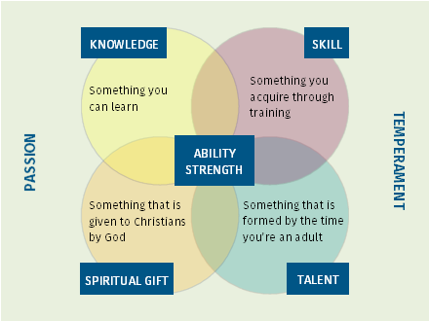

Talent x Investment = Strength.

#### For reflection

What are your strengths, the things that when you do them they bring ‘strength’ to you?

### Work on Gaps

Things don’t have, but can get.

#### For reflection

What are your skills gaps it would be good to fill?

What knowledge would it be beneficial to gain?

### Manage Around Limitations

Things don’t have, and can’t easily get.

A limitation is anything that gets in the way of excellent performance in your role.

#### How to deal with talent limitations

#### For reflection

What are your limitations?

‘God can achieve his purposes either through the absence of human power and resources, or the abandonment of reliance on them. All through history God has chosen and used nobodies, because their unusual dependence on him made possible the unique display of his power and grace. He chose and used somebodies only when they renounced dependence on their natural abilities and resources.’

Oswald Chambers

### Grow Through Weaknesses

Things do have, but don’t want.

#### 1. Infirmities, 2 Corinthians 12:7-10

#### 2. Ordinariness, 1 Corinthians 1:26-29

#### For reflection

What are the infirmities you currently face?

What can you do to embrace ordinariness?

‘‘All human beings have their flaws, but not all of us realise them, come to grips with them, or offset their negative impact. As a group whose primary endeavour is interacting with people, leaders must accomplish the paradoxical task of managing their darker sides.’

Abraham Lincoln

### Engage with Flaws

Things do have, and often avoid.

Cracks in our character that, not properly dealt with, will derail our lives.

#### For reflection

What flaws are you currently aware of?

### Kingdom Paradox 1

If we want to lead, we must first be led.

 ‘But I am also getting in touch with the mystery that leadership, for a large part, means to be led.’

Henri Nouwen

### Kingdom Paradox 2

We serve people/those we lead. They are not our master.

* We serve others. We don’t necessarily do what they want.

* Is someone other than Jesus your master?

### Kingdom Paradox 3

Maximum influence is gained through humility, vulnerability and focus.

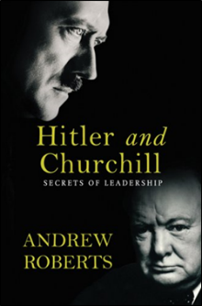

### Leading Like Jesus

In what way is Jesus a good model?

‘Against all leadership counsel we have to set Jesus, and not so much figure out how to be leaders from what he said and did but enter into the world that he lived in, the relationships that he cultivated, and assimilate his style. This leadership is not techniques and strategies culled from a superficial reading of the gospels that knows little of Jesus himself, but a Jesus-leadership spirit, mind, sensitivity. It is a leadership that is conspicuously lacking in the exercise of power and the attraction of followers.’

The Unnecessary Pastor, Eugene Peterson, p.190

What are some of the wrong ways of seeing Jesus as our model?

‘The study of Jesus does not provide us with a ‘how to’ recipe i.e. how to be a leader like Jesus. Rather we learn that Jesus in us continues to lead through us.’

Transforming Leadership, Leighton Ford, p.32

Leading like Jesus is beyond adhering to a philosophy, adopting a methodology, imitating a personality, mastering a competency, and responding to a challenge. Leading like Jesus is a life-long learning process of being formed in Christ-like character and growing in leadership ability that reflects our strengths and the needs of the community we serve.

### Christian Leadership is...

A servant oriented relationship

whereby those who lead,

under God’s leadership,

through Christ-like example,

and stewarding their God given capacity,

seek to nurture others towards

kingdom honouring attitudes and actions.

‘The most creative Christian leadership is that which is deeply rooted within the life of God.’

Elizabeth Welch

‘Despite the multitude of ways that leadership has been conceptualised, several components can be identified as central to the phenomenon of leadership. They are:

(a) Leadership is a process.

(b) Leadership involves influence. (c) Leadership occurs within a group context.

(d) Leadership involves goal attainment.’

Leadership Theory and Practice, Peter Northouse