## Introduction

### Overview

· Why would we want to discern direction?

· Explore some current thinking about what we mean by ‘vision’ and leading a process of discerning direction.

· Some practical help in leading people in discerning God’s direction.

**Key question** – how do we guide God’s people through a process of discerning direction?

### Part 1: Defining Terms

#### What do we Mean by the Term Vision?

* Vision (noun) 1. The faculty or state of being able to see. 2. The ability to think about or plan the future with imagination or wisdom – a mental image of what the future will or could be like. 3. An experience of seeing something in a dream or trance, or as a supernatural apparition.’ Concise Oxford English Dictionary
* ‘An institutional vision is a clear and challenging picture of the future of the ministry as you believe it can and must be.’ Aubrey Malphurs
* ‘Vision for ministry is a clear mental image of a preferable future imparted by God to his chosen servants and is based upon accurate understanding of God, self and circumstances.’ George Barna
* ‘For organisations, a vision is an attractive, ideal future that everyone in the organisation can believe in, one that can realistically be achieved, yet offers a future that is better in important ways than what now exists.’ Richard Daft
* ‘Simply a picture of an ideal state of what the leader wants his or her organisation to be some time in the future.’ Matthew Richter
* ‘A clearly communicable picture of the future, steeped in value and philosophy, as well as structure.’ Stan Slap
* ‘Vision starts with frustration over what is and develops with determination to press towards what could be. Vision originates with the indignation of hindsight, the illumination of insight, and the imagination of foresight.’ David Pytches
* ‘Vision is like a magnifying glass which creates a focus, a bridge which takes us from the present to the future.’ Leighton Ford
* ‘Vision is seeing tomorrow so powerfully that it shapes today.’ Walter Wright
* ‘Vision is a powerful sense of what needs to be done and the initiative to take hold of it and work towards its completion.’ Ian Parkinson
* ‘Vision is the interpretation and application of mission into a specific context. In the church, vision sees, with an eye of faith, the ways that we can turn the Great Commission into a reality.’ Eddie Gibbs

#### Key Insights

‘If any one idea about leadership has inspired organisations for thousands of years it’s the capacity to hold a shared picture of the future we seek to create. One is hard pressed to think of an organisation that has sustained greatness in the absence of goals and missions that become deeply shared throughout the organisation.’

Peter Senge

‘Visions are like lenses. They focus unrefracted rays of light. They enable everyone concerned with an enterprise to see more clearly what is ahead of them.’

Kouzes and Posner

‘There is no shortage of vision. The challenge of leadership is to gather all the vision from inside and outside the organisation, extract the best that matches the mission, and then craft a vision statement that will unite the people in moving forward toward the common goal and a more desirable future.’

Leith Anderson

## Defining Terms

### A Framework

#### Identity

Who are we?

#### Values

How do we do things?

#### purpose

Why do we exist?

#### Vision

Where are we heading?

#### Strategy

How will we get there?

#### Structure

How do we need to organise ourselves?

### Discerning God’s Call

Finding and fulfilling the central purpose for our corporate life.

#### how

### Delivering kingdom-honouring service

The outworking of all this is not personal gain or public success, but   
Christ-like service for kingdom purposes in God’s world.

#### why

#### Review/Revise

### A Summary of Definitions

#### Identity

* Answers the question, who are we?
* Helps shape belonging and involvement.
* For a church its identity is given by Christ. We’re the body of Christ.

#### purpose

* Answers the question, why do we exist?
* It is an enduring statement that doesn't change. God decides the mission of a church (great commandment and great commission).
* Likely to be a short statement, and may be captured in a short pithy slogan or strap line.
* Mission needs to have a sense of ‘ooomph’ about it.

#### Values

* Answer the question, what guides how we do things? i.e. we're committed to doing things...
* Helps define distinctives. Values are what drive us on.
* Ideally relatively small in number, probably around four to six.
* Values need to have a sense of ‘aha’ about them.

#### Vision

* Answers the question, where are we heading? Where are we called to go?
* It is always future oriented. It needs to include destination, be clear, compelling and capturing. Vision often uses a refrain or a mental image, or a word picture to capture the imagination.
* It will be longer than the mission statement, and not a slogan.
* It will change as the circumstances of the organisation/church and character of individuals change, and as the vision is realised.
* It needs a time frame, probably 1-3 years, 3-5 years, or 5-10 years. However, after one year the vision will need to be reviewed and refined because of changing circumstances.
* Vision needs to have a sense of ‘WOW’.

#### Strategy

* Answers the question, how are we going to get there? Or how do we intend to realise the vision in a way that fulfils our mission and values? What areas of our activity will need to change?
* Targets (or aims): ideally four or five major things that need to happen to get us from where we are to where we want to be.
* Tasks (or goals/objectives): these are practical steps broken down into priorities, plans, action, responsibilities and timing. Ideally they need to be SMART (Simple, Measurable, Achievable, Reviewable, Timed).

#### Structure

* Answers the question, how do we organise ourselves to fulfil our mission.
* Structures need to serve strategies, not maintain the status quo.

#### Review/revise

* Answers the question, when do we know we’re there?
* A cartoon character standing on a path with arrows pointing to the sides

  Description automatically generatedEnables people and organisation to learn, develop, improve, grow.

**Key Insights**

‘It is rare to find a congregation that has developed a mission statement out of Scripture study and then refocused all their activity to reflect that statement. It is even rarer to find Christian organisations that have done the hard biblical work of defining why they do what they do, organisations that have actually drafted what I call an operational theology of their mission… I can guarantee that when we work largely from unstated assumptions in our personal lives, churches or organisations, the values of the dominant culture are going to slip in and shape not only what we do, but how we do it. And we won’t even notice.’

Tom Sine

‘Vision is the interpretation and application of mission into a specific context. In the church, vision sees, with an eye of faith, the ways that we can turn the Great Commission into a reality. Whereas mission identifies what we are doing or should be attempting, vision is concerned with what we should become in order for that vision to be realised in our particular context.’

Eddie Gibbs

## What Does Vision Do?

#### Vision

* Generates hope.

* Sets direction.

* Provides clarity.

* Creates ownership.

#### Characteristics of a good vision

* Imaginable.

* Desirable.

* Feasible.

* Focused.

* Flexible.

* Communicable.

## Vision Matters Because Situations Change

### Situations Change

#### The Congregational Life Cycle

#### Redefinition

#### Redevelopment

#### Rebirth

#### Stability

#### decline

#### Monument

#### mausoleum

#### ministry

#### growth

#### mission

#### movement

#### birth

#### death

* Where are you on the curve?

* What has taken you to that place?
* What do you need to give attention to at this stage?

**Key Insights**

‘There is no shortage of vision. The challenge of leadership is to gather all the vision from inside and outside the organisation, extract the best that matches the purpose, and then craft a vision statement that will unite the people in moving forward toward the common goal and a more desirable future.’

Leith Anderson

‘Vision leaks. It needs to be communicated clearly, creatively and continually’.

John Maxwell

## VUCA-G World

* Volatile.

* Uncertain.

* Complex.

* Ambiguous.

* Global.

For more on this see VUCA and how to respond to it see [www.forbes.com/sites/dedehenley/2024/05/19/the-vuca-world-is-now-heres-how-to-face-it/](https://www.forbes.com/sites/dedehenley/2024/05/19/the-vuca-world-is-now-heres-how-to-face-it/).

#### BANI World

* Brittle.

* Anxious.

* Non-linear.

* Incomprehensible.

For more on BANI see [www.forbes.com/sites/jeroenkraaijenbrink/2022/06/22/what-bani-really-means-and-how-it-corrects-your-world-view](https://www.forbes.com/sites/jeroenkraaijenbrink/2022/06/22/what-bani-really-means-and-how-it-corrects-your-world-view/).

#### Key Insights

‘Refocusing our vision in the Church means being able to see what God is still making possible.’

Elisabeth Welch

## Discerning Direction in an Uncertain World

#### Insights from Tod Bolsinger video’

‘The world in front of you is nothing like the world behind you.’

Tod Bolsinger

#### How are the missional circumstances of your church and the character of the individuals you’re serving changing?

#### Resources

* Canoeing the Mountains, Tod Bolsinger (IVP)
* Quietly Courageous, Gil Rendle (RLPG/Galleys)
* A Non-Anxious Presence, Mark Sayers (Moody)
* Rebuilders Podcast, Mark Sayers

## Discerning God’s Direction in a Culture of Change

* Non linear.

* Fluid.

* Complex not complicated.

Linear vs Non Linear Discerning Direction

Strong Connection to Adaptive Leadership (see notes from first residential).

|  |  |
| --- | --- |
| Linear | Non Linear |
| 1. Clear problem.  2. Known Solution.  3. Action. | 1. Presenting Issue.  2. Complex Interaction.  3. Learning. |
| Method | |
| 1. Where are we now?  2. Cast Vision.  3. Measure the gap.  4. Identify the steps. | 1. Connect to the realistic pain.  2. Capture the possibility.  3. Challenge to step out of the box.  4. Accompany into subsequent chaos.  5. Support learning and reordering. |

## The Role of the Leader

‘The great Christian revolutions came not by the discovery of something that was not known before. They happen when someone takes radically something that was always there.’

Richard Neibuhr

**Triple Listening**

1. Listening to God.

2. Listening to my context.

3. Listening to others.

‘The best leaders are great listeners. They listen carefully to what other people have to say and how they feel. They have to ask good questions, be open to ideas other than their own, and even lose arguments in favour of the common good.’

Kouzes and Posner in the Leadership Challenge

#### Who should be involved in the process?

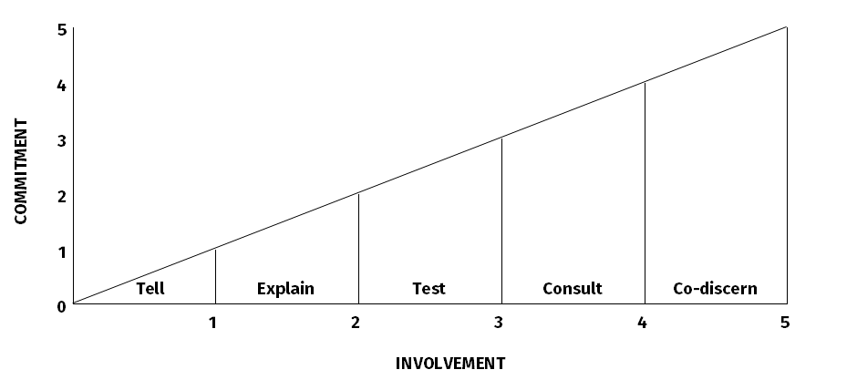

**Thinking about the vision statements that you brought with you today:**

* What evidence can you see that you are moving towards that vision?

* What level of ownership would you say it has in the wider church?

* What do you think needs to happen in response to your answers and what could you do in your role?

#### The Role of the Leader

1. To initiate and steer the process.

2. To define reality and foment dissatisfaction.

3. To regulate the pace.

4. To ensure clarity, communication and ownership.

5. To challenge timidity.

6. To maintain spiritual integrity.

#### Questions to ask before embarking on a process of discerning direction

1. Is this the right step for us at this time?

2. What approach are we going to use?

3. Who are we going to involve?

4. How far ahead are we looking?

5. How long will we spend?

6. What resources will we use?

7. What are we aiming to produce as a result of this process?

#### Key Insights

‘Vision is a product of God working in us. He creates the vision and we receive it; it becomes a rallying point, a goal towards which we move as his people… Vision arises out of our burden to know the will of God… it calls us forth.’

Terry Fulham

‘Vision may begin with one person, but it is accomplished only through the efforts of many people.’

John Maxwell

‘Articulating the vision may be the single most important responsibility that a leader has.’

Walter Wright

## The Process

## A Variety of Models

### Approach 1: Simple

Answer the question ‘where would God want us to be in three years time?’

* Ask people in casual conversation.

* Ask everyone to pray, think and listen attentively.

* Ask those in leadership with you.

### Approach 2: Staged

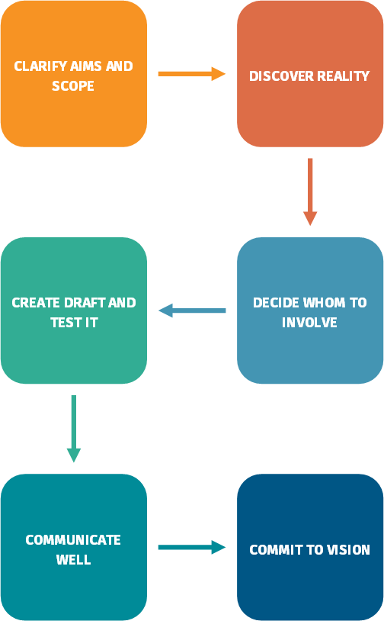

### Approach 2: Staged

#### Step 1: Clarify Aims and Scope

* Why this process at this time?

#### Step 2: Discover Reality

* The importance of problem casting.
* The importance of refusing to minimise difficulties.
* Using a variety of tools including e.g. SWOT analysis.
* Understanding the power of creative tension.

#### Step 3: Decide whom to involve

* Depends on size of church.
* Always involve those whose positional role gives them particular responsibility for area under consideration.
* Don’t avoid the challenging voices.

#### Step 4: Create draft and Test it

* Key stakeholders.
* Those directly affected by the proposed vision document.

#### Step 5: Communicate it well

* Stimulating imagination as well as intellect.
* Reinforcing it by how we deploy ourselves.

#### Step 6: Commit to it

* Leaders are called to commit to the vision, to embody it in their daily life, be prepared to pay a price, to make hard decisions. There is only one thing worse than no vision, and that is a long and costly process of discerning a vision which produces passion in people… and then nothing is done about it!

#### Key Insights

‘The essence of leadership is the ability to influence others to volunteer their separate energies and resources to a common pursuit. This rests on the leader’s ability to communicate the vision in a clear, convincing and compelling manner. The communication must excite not only people’s intellects but also their imagination and passion.’

Shawchuck and Heuser

‘Both formal and informal leaders communicate their vision by how they spend their time, what they talk about, what problems they solve first, and what they get excited about. In every act, leaders reinforce the values they hold and the vision they hope to achieve.’

Bennis and Nanus

### Approach 3: Story

Appreciative Inquiry (AI) is a particular way of asking questions and envisioning the future that fosters positive relationships and builds on the basic goodness in a person, a situation, or an organisation. In so doing, it enhances a system’s capacity for collaboration and change. Appreciative Inquiry utilises a cycle of four processes focusing on:

* **Discovery** Appreciate the best of what is.
* **Dream** Imagine what could be.
* **Design** Determine what should be.
* **Direction** Create what will be.

The basic idea is to build organisations around what works, rather than trying to fix what doesn’t. It is the opposite of problem solving. Instead of focusing on gaps and inadequacies to remediate skills or practices, AI focuses on how to create more of the exceptional performance that is occurring when a core of strengths is aligned. It opens the door to a universe of possibilities, since the work doesn’t stop when a particular problem is solved but rather focuses on ‘What is the best we can be?’ The approach acknowledges the contribution of individuals, in order to increase trust. The method aims to create meaning by drawing from stories of concrete successes and lends itself to situations where confidence is low, people have been ‘burned’ by other approaches, and collaboration is key to forward movement.

(Taken from Wikipedia, adapted.)

#### Key Insights

AI assumptions:

* In every organisation some things work well.
* What we focus on becomes our reality.
* Asking questions influences the group.
* People have more confidence in the journey to the future when they carry forward parts of the past.
* If we carry parts of the past into the future, they should be what is best about the past.
* It is important to value differences.
* The language we use creates our reality.
* Organisations are heliotropic (they lean towards a source of energy – healthy or unhealthy).
* Outcomes should be useful.
* All steps are collaborative.

Mark Branson, Memories, Hopes and Conversations, The Alban Institute

See also Congregations as Learning Communities, Dennis Campbell, Alban Institute

#### Key resources

[www.alban.org/conversation.aspx?id=3674](http://www.alban.org/conversation.aspx?id=3674) for an expanded version of the ten assumptions listed above.

[www.vancouver.anglican.ca/Portals/0/Repository/AppreciativeWayredesigned.c77309b2-b03f-440e-bf4b-d01e29268ef1.pdf](http://www.vancouver.anglican.ca/Portals/0/Repository/AppreciativeWayredesigned.c77309b2-b03f-440e-bf4b-d01e29268ef1.pdf) for a guide to conducting an appreciative inquiry session.

[www.clergyleadership.com](http://www.clergyleadership.com) for a website dedicated to appreciative inquiry in churches.

#### Choose a process. From your insights today:

* What are the advantages and disadvantages of them?

* What circumstances might you envisage using each process?

* How might you maintain a missional focus?

* Anything else to consider?

* What other processes have you used?

## Next Steps

#### Key insights

#### Remaining Questions?

#### Next steps