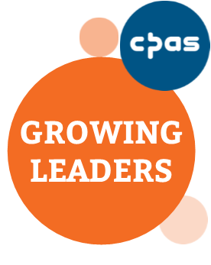
growing leaders programme

[Insert Name] has almost completed the Growing Leaders programme. GL emphasises that gifts are not only exercised in community for the building up of the body, but also discerned in community and we are now seeking with each participant to discern their next steps in service and development.

- Attendance on programme:

- Observed engagement with GL programme (e.g. contribution to group, relationship with mentor, service).

- Observed or experienced areas of gifting.

- Observed or experienced personality and character traits.

- Observed or experienced relationships with others.

- Any encouragements or particular concerns that should be noted as future ministry responsibilities are considered for this person.

- Thoughts on future training and development needs.

- Any other comments.

