#### The story so far...

* Personal vision is about finding and fulfilling God’s call for our life, giving direction to how we use our time and talents, and invest our energy and attention.

* The PVS is a tool to help us discern more clearly God’s big yes in our lives and then live that out. It is about seeing the whole of life (not just our leadership role) as part of God’s call on us to live life the Jesus way.

* Our goal is to glorify God and be fruitful in good works through a surrendered life, leading to an abundant life, lived out in a blended life.

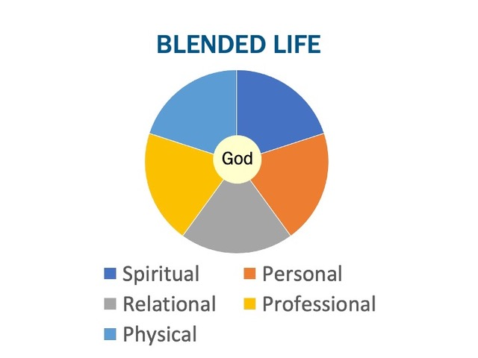

* We hold In tension self denial and self care.

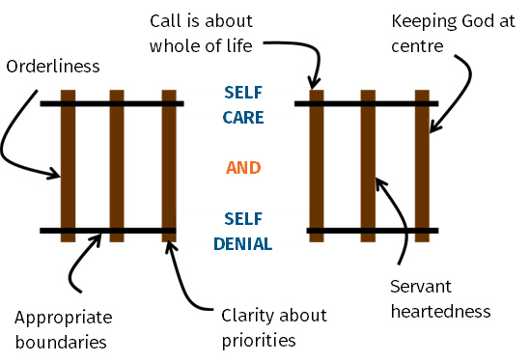

* Boundaries are important, and it helps to know where we generally locate ourselves on the boundary spectrum, and to be open to moving.

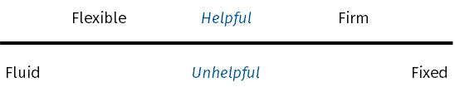

#### STRUGGLES WE HAVE

1. Have too little time to do something.

1. Have too much to do.

1. Working inefficiently.

#### EXERCISE

If you had to identify an issue for you in personal organisation, what would it be?

### 

### 

### 

### 

### 

### 

### 

### 

### 

### 

### 

### 

### 

### 

### 

### 

#### Spectrum of personal organisation

### 

### 

### 

### 



### Orderliness

The ordering of our lives in a way that...

glorifies God...

reflects who we are…

recognises the nature of our leadership role...

accepts our responsibilities...

embraces our season of life…

discerns God’s priorities

and increases our ability to do good works.

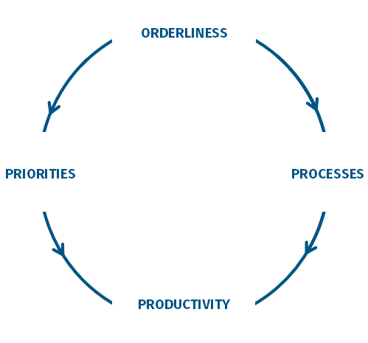

#### Three understandable excuses

1. Others are better at this than me, I’ll delegate it to them.

2. My personality means that I’m not wired to be good at this.

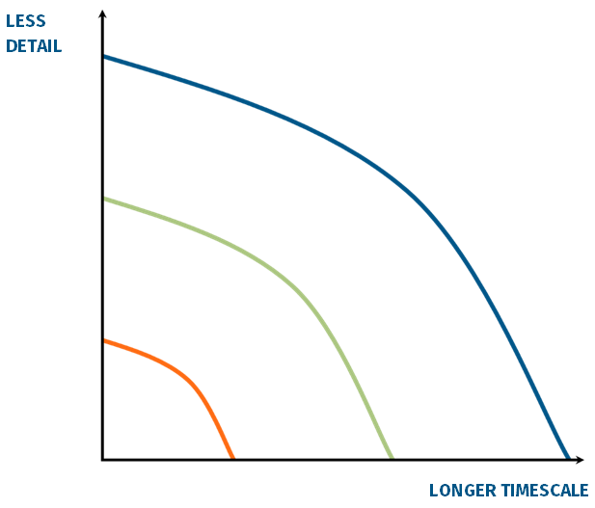

3. I’m a creative/ideas type. Order cramps my style.

How creative are you on a scale of 1-10? ­____

How efficient are you on a scale of 1-10? ____

#### The Key

#### EXERCISE

Think about someone you know who may be less ordered than is helpful.

* What impact does a lack of orderliness have?

* Who is most affected and why?

#### 

#### A quick questionnaire

*On your desk:*

• Do you have everything you need? Yes / No

• Does it work? Yes / No

• Can you access it easily? Yes / No

• Do you have a way of collecting everything that comes in in one place? Yes / No

*When filing (both electronic and paper):*

• Is it easy? Yes / No

• Is it fun? Yes / No

• Is it fast? Yes / No

• Can you find what you want quickly? Yes / No

*The room where you work:*

• Is the lighting great? Yes / No

• Does the environment inspire you? Yes / No

• Are you comfortable? Yes / No

• Are you relaxed? Yes / No

• Is it free of distractions? Yes / No

*When processing work:*

• Do you have a helpful way of organising everything you need to do? Yes / No

• Do you have an effective way of processing paper? Yes / No

• Do you have a way of processing your emails that ensures a zero inbox? Yes / No

• Are you known for not missing appointments? Yes / No

• Do you return calls/answer texts on time? Yes / No

• Do you have a way of arranging what to do when? Yes / No

• Do you ‘batch’ similar work? Yes / No

• Do you feel reasonably in control of your workload/flow? Yes / No

### Physical Space

* Desk.

* Décor.

### Processes or Systems

A good system will have the following characteristics (adapted from Mark Forster, Secrets of Productive People p.112):

* Simplicity It should be easy to use.
* Drawing power It should draw you into your work and help overcome procrastination and resistance.
* Thoroughness It should encourage work to completion.
* Self-limiting It should restrict you to do what can actually be done on any day. It should not result in backlogs, half done projects.

#### PRINCIPLE 1. Get stuff out of your head

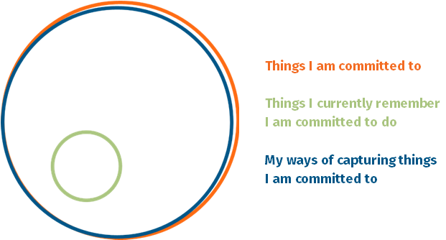

Three tools for capturing stuff:

1. Scheduling tool.

2. Task management tool.

3. Information tool.

#### PRINCIPLE 2. work in focused chunks

Create focus by:

* Getting rid of distractions.

* Working in set chunks of time i.e. 90 minutes.

* Batching. Doing like items together.

#### PRINCIPLE 3. CREATE EFFECTIVE SYSTEMS AND MASTER THEM

Remember, there is no one way of doing this. Find a system that works for you, and master it.

#### GuIdelines for using a diary WELL

**Use it recognising the realities of your role.**

* Plan for admin.

* Plan for interruptions.

* Plan knowing your attention flow.

* Plan for meetings.

* Plan for getting behind.

* Plan for time to pray and think.

* Plan knowing not enough time in one day to do everything, but in a week there might be.

#### 

#### GUIDELINES for using lists well

#### 

**Types of list:**

**Check list** This is the most basic list. Anything that you do regularly that requires eye for detail, create a check list.

#### 

#### 

#### 

#### 

Then there are four levels of list one can work with.

* **Projects list** A project is any action that requires more than two steps to complete it.

* **Master actions list** Contains every single action you need to do to complete any and every project.

* **Daily to do list** What you are going to do today, ideally no more than five things.

#### 

#### 

#### 

#### 

#### 

#### 

* **Waiting for list** Tracking all the people you are waiting for to do something.

#### 

#### 

#### 

#### 

#### 

#### Guidelines for using an information system well

Three levels:

1. Working.

2. Reference.

3. Archive.

Any system needs to be fast, easy, simple and ideally fun!

See additional handout on how to set up a filing system.

#### Guidelines for creating a good system for handling emails

We all have a system for our emails, the question is does it enable us to respond to emails in a timely fashion and does it cause us stress?

See additional handout on handling emails.

### And Finally – A Guide to Being Unproductive

* Never say no to anyone.
* Pay no attention to developing good systems.
* Start lots of things which you don’t finish.
* Do nothing to avoid distractions and interruptions.
* Avoid getting interested in what you are doing.
* Allow backlogs to build up.
* Leave stuff to the last minute and beyond.
* Think that you are naturally disorganised and there’s nothing you can do about it.
* Follow the path of least resistance – go for what is easy rather that what is essential.
* Get submerged in trivial busy work.
* Have more commitments than you have time to complete.
* Don’t ask for advice.
* Don’t identify what’s really important.
* When something goes wrong work round it instead of sorting it out.
* Make sure you forget important tasks by not writing them down.
* Take on so much work that you don’t have time to concentrate on anything.
* Keep chopping and changing your priorities so nothing gets properly developed.
* Ensure that your important work is constantly interrupted by trivial things going wrong because your low-level systems (i.e. how to handle email) don’t work properly.
* Introduce a new system at least once a year so that you never really get to grips with any system properly.
* Don’t spend time thinking about anything for too long.

This approach can be summarised under three headings:

1. Be unsystematic.

2. Overload yourself.

3. Don’t follow through.

#### The ones to read

* Do More Better, Tim Challies (Cruciform Press)
* Beyond Busyness, Stephen Cherry (Sacristy Press)
* How to be a Productivity Ninja, Graham Allcott (Icon Books)
* Time for Everything, Matt Fuller (The Good Book Company)
* What’s Best Next, Matt Perman (Zondervan)
* Andy Crouch, The Tech-Wise Family (Baker Books)
* Tony Reinke, 12 Ways Your Phone is Changing You (Crossway)

#### If you want more...

* Do It Tomorrow, Mark Forster (Hodder)
* The Busy Christians Guide to Busyness, Tim Chester (IVP)
* Secrets of Productive People, Mark Forster (Teach Yourself)
* Driven Beyond the Call of God, Pamela Evans (BRF)
* Busy Christian Living, Emma Ineson (Continuum)
* Getting Things Done, David Allen (Piatkus)
* Ordering Your Private World, Gordon Macdonald (Thomas Nelson)
* Deep Work, Cal Newport (Piatkus)
* The World Beyond Your Head – How to Flourish in an Age of Distraction, Matthew Crawford (Penguin)

#### Apps

* Todoist – across platform task management App.
* Asana – for cross team working.
* Planning Centre – for church rotas, worship, finance, people, room booking.
* Monday.com – for church management (specific version).
* Forest App – creative way of helping us leave our phones alone when we don’t want to be distracted by them.
* Pomodoro – timer Apps to use to help do focused chunks of work.

#### On procrastination

* [www.psychologytoday.com/us/basics/procrastination](http://www.psychologytoday.com/us/basics/procrastination)
* [www.mindtools.com/pages/article/newHTE_96.htm](http://www.mindtools.com/pages/article/newHTE_96.htm)
* <https://jamesclear.com/procrastination>

#### Websites

* [www.thinkproductive.co.uk](http://www.thinkproductive.co.uk)
* [www.whatsbestnext.com/resources/productivity](http://www.whatsbestnext.com/resources/productivity), includes an excellent article on getting your inbox to zero.
* [www.markforster.squarespace.com](http://www.markforster.squarespace.com)
* [www.lifehacker.co.uk](http://www.lifehacker.co.uk)
* [www.bulletjournal.com](http://www.bulletjournal.com)