### Session Aims

* To continue the process of discerning God’s vision for our lives.
* To explore practical ways to live out God’s call on our lives.

### Introduction and Review

* Red zone and tick-over living.

* Primary and secondary calling.

* Vision is like a magnifying glass – it helps create focus.

* Developing a personal vision statement (PVS) is like a compass – it helps bring direction.

### Approaches

* Work ethic.

* Leisure ethic.

* Bible centred ethic.

### https://pixabay.com/get/g95c1c86d7074a479d04b82038a80af0abcf441dbc71d88ec1f739e7516fcd4e9793d6d72270ad03f647fd877483920f8_1920.jpgBalanced Life?

* Involves strain and stress.

* Unhelpfully compartmentalises life.

* Misleadingly simplifies life.

* Times where Jesus’ teaching is not at all balanced.

‘Leisure is no longer rest. Leisure is consumption.’

‘Busyness is not a problem. In anybody’s life there will be periods of intense activity. The problem comes when we are persistently over-busy. If your life doesn’t reflect the biblical pattern of work and rest then something is wrong.’

Tim Chester

### Our Goal?

The goal is to _______________________ God

and be ____________________ in good works

through a ________________________ life

leading to an ________________________ life

lived out in a ______________________ life.

#### Guideline 1: Put Stones in first

#### Guideline 2: work with natural rhythms

* Recognise daily rhythm.

* Recognise weekly rhythm.

* Recognise monthly/termly rhythm.

* Recognise yearly rhythm.

‘Sometimes our busyness results from our own insecurity.’

Ajith Fernando

|  |  |
| --- | --- |
| **How much rest?** | **How much work?** |

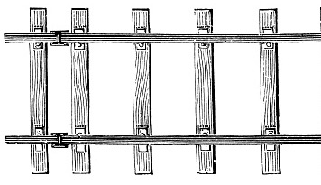

#### Guideline 3: Create specific goals from our PVS

#### Guideline 4: Plan a week at a time

* Roles.

* Goals.

#### Guideline 5: Exercise integrity at all times

#### 

#### Guideline 6: Make yourself accountable to others

#### 

#### Guideline 7: Revise your PVS regularly

‘In the absence of clearly defined goals, we become strangely loyal to performing daily trivia, until ultimately we become enslaved by it.’

Robert Heinlein

‘The main thing is to keep the main thing the main thing.’

Stephen Covey

‘Make sure your life sings the same song as your lips.’

St. August

### Questions to Use for Reflection

* What have I learned about God and myself over the last year?

* What has changed in my personal, family or work life?

* What needs changing in the light of the answers to the previous questions to ensure my vision statement continues to reflect where I sense God is leading me?

### A Final Thought – beware PESTs

**P**ressure.

**E**xpectations.

**S**in.

**T**yranny of the urgent.

‘Spend your time in nothing which you know must be repented of; in nothing on which you might not pray for the blessing of God; in nothing which you could not review with a quiet conscience on your dying bed; in nothing which you might not safely and properly be found if death should surprise you in the act.’

Richard Baxter

### Driven Beyond the Call of God

* I’m overbusy because I need to prove myself.

* I’m overbusy because of other people’s expectations.

* I’m overbusy because otherwise things get out of control.

* I’m overbusy because I prefer being under pressure.

* I’m overbusy because I need the money.

* I’m overbusy because I want to make the most of my life.

Taken from The Busy Christian’s Guide to Busyness, Tim Chester, IVP

‘If I am a member of the body of Christ, it is not really a matter of “where do I want to go?” but rather “where does he want to take me?”’

Terry Fulham

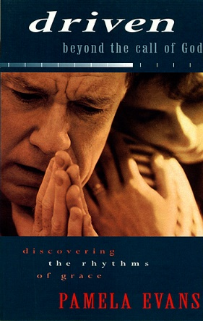

### Development Goal Option

Read chapters 7-12 of Tim Chester’s book and identify which issue is likely to drive you beyond the call of God. Create a poster to remind you of this issue and what you are going to do about it. Put it somewhere visible.

You may also like to read Driven Beyond the Call of God, Pamela Evans, BRF, chapter one ‘What’s driving you?’ and chapter six ‘Authority and Leadership’.