### Change vs Transition

### Pattern of Change

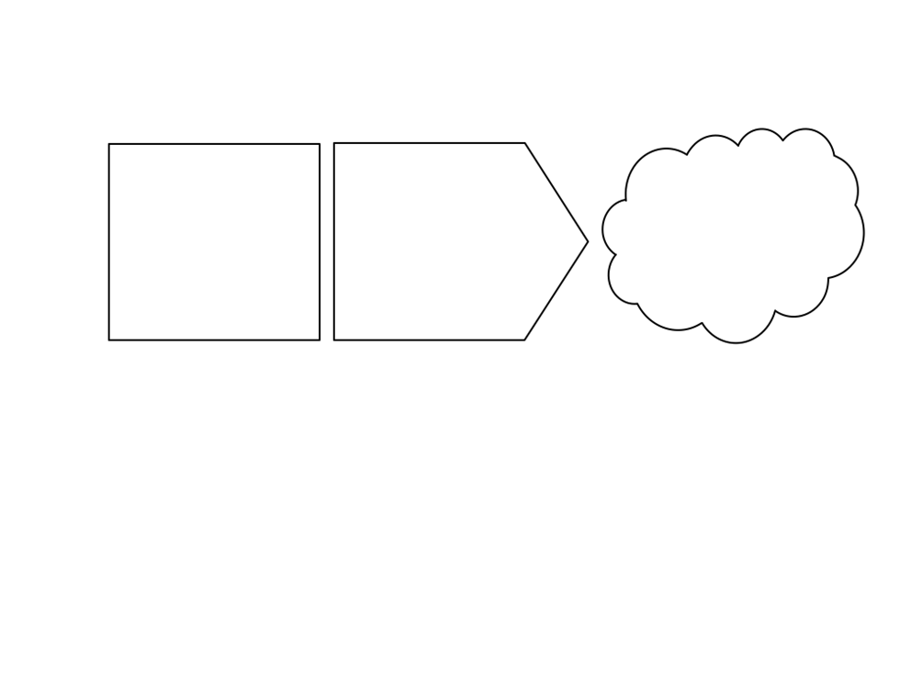

### Positive Change

#### Uninformed optimism

#### Realistic optimism

#### informed pessimism

#### Unrealistic pessimism

Source: The career/entrepreneurial transition curve

### Negative Change

### 

#### Anger

#### bargaining

#### acceptance

#### depression

#### Denial/rejection

### 

### 

### 

### 

### 

### 

Facing

Backwards

Forwards

### 

### 

### 

### 

Source: On Death and Dying, Elisabeth Küber-Ross, 1969

### Four Key Roles

We must do what we   
conceive to be the right things and not bother our heads or burden our souls with whether or not we’re going to be successful. Because if we don’t do the right things, we’ll be doing the wrong thing and we’ll just be part of the disease and not part of the cure.

**E F Schumacher**

### Change vs Transition

### Pattern of Change



### Positive Change

#### Uninformed optimism

#### Realistic optimism

#### informed pessimism

#### Unrealistic pessimism

Source: The career/entrepreneurial transition curve

### Negative Change

### 

#### Anger

#### bargaining

#### acceptance

#### depression

#### Denial/rejection

### 

### 

### 

### 

### 

### 

Facing

Backwards

Forwards

### 

### 

### 

### 

Source: On Death and Dying, Elisabeth Küber-Ross, 1969

### Four Key Roles

We must do what we conceive to be the right things and not bother our heads or burden our souls with whether or not we’re going to be successful. Because if we don’t do the right things, we’ll be doing the wrong thing and we’ll just be part of the disease and not part of the cure.

E F Schumacher

### 

### 

### 

### 

### Principles

’Show up. Speak up. Look up. Team Up. Don't give up. Lift others up.’

Rosabeth Moss Kantar



### Approaching the Difficult Conversations

#### consent

#### commit

#### test

#### +

#### Perceive

#### Understand – why and what

#### Engage – implications

#### Aware – something

#### -

### Four Main Reasons

### Six Main Strategies

